Making a SGDe Game

Last edited-2/23/2011

By Vinnie Simonetti

The following is a document describing how to create a new SGDe based game.

Note some screens might not match. Be sure to read the document carefully.

# Creating a project

This assumes that you have the newest version of XNA installed and integrated with Visual Studio.

The first step is to create the project in Visual Studio.

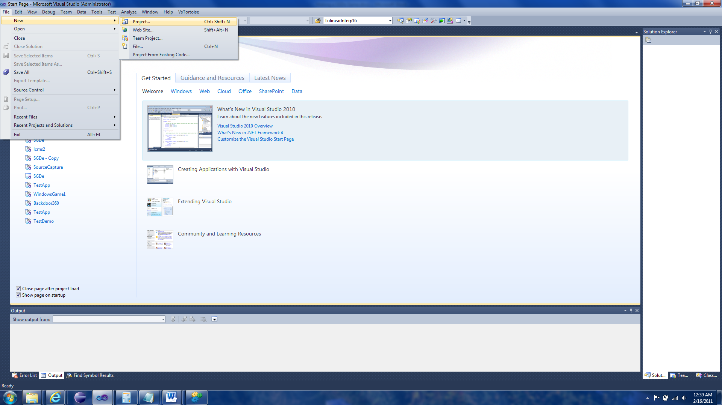

The next step is to choose an XNA Project

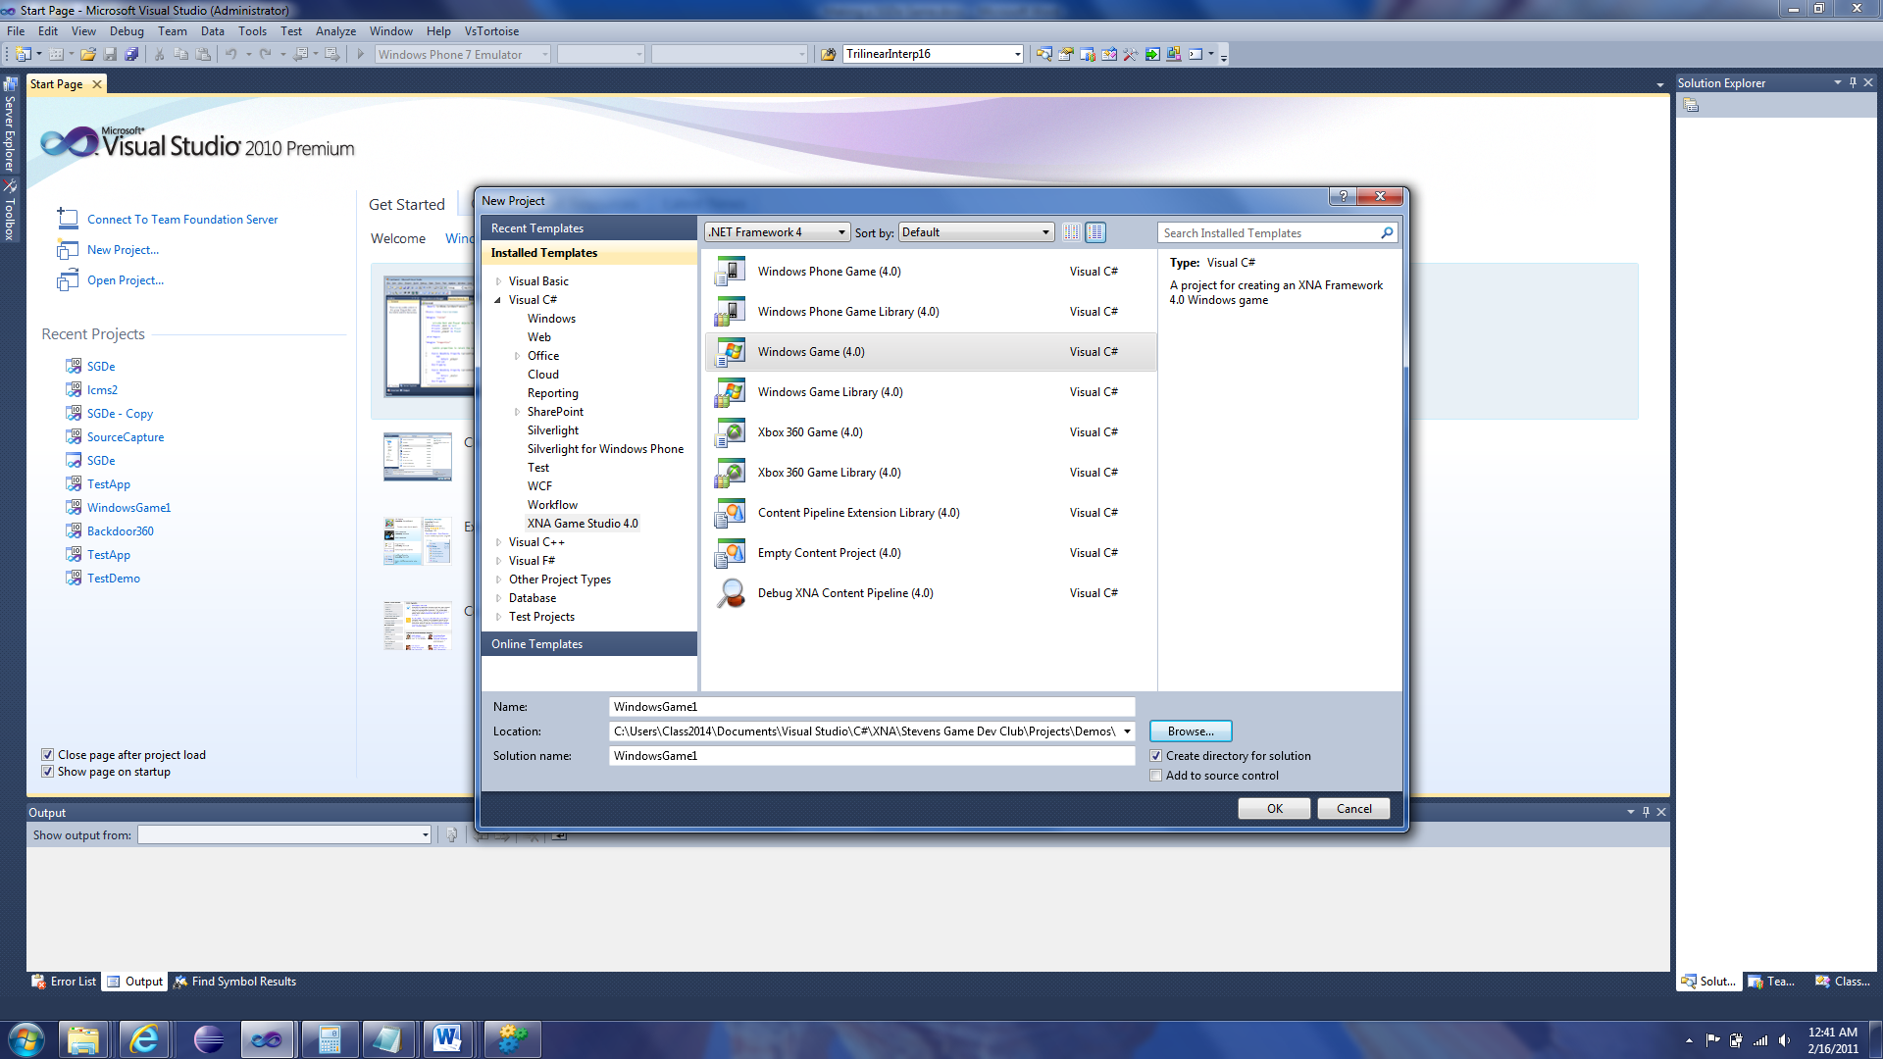

If you are developing a Windows Phone game, you choose the “Windows Phone Game”; Xbox 360, “Xbox 360 Game”; Windows Game, “Windows Game”.

Choose its location to save, give it a name (I will leave the project’s default name), and click OK.

If you tried to run the game, you should simply have “CornflowerBlue” screen show. That’s all.

Now we need to add references to SGDe so you can change the project to be a SGDe game.

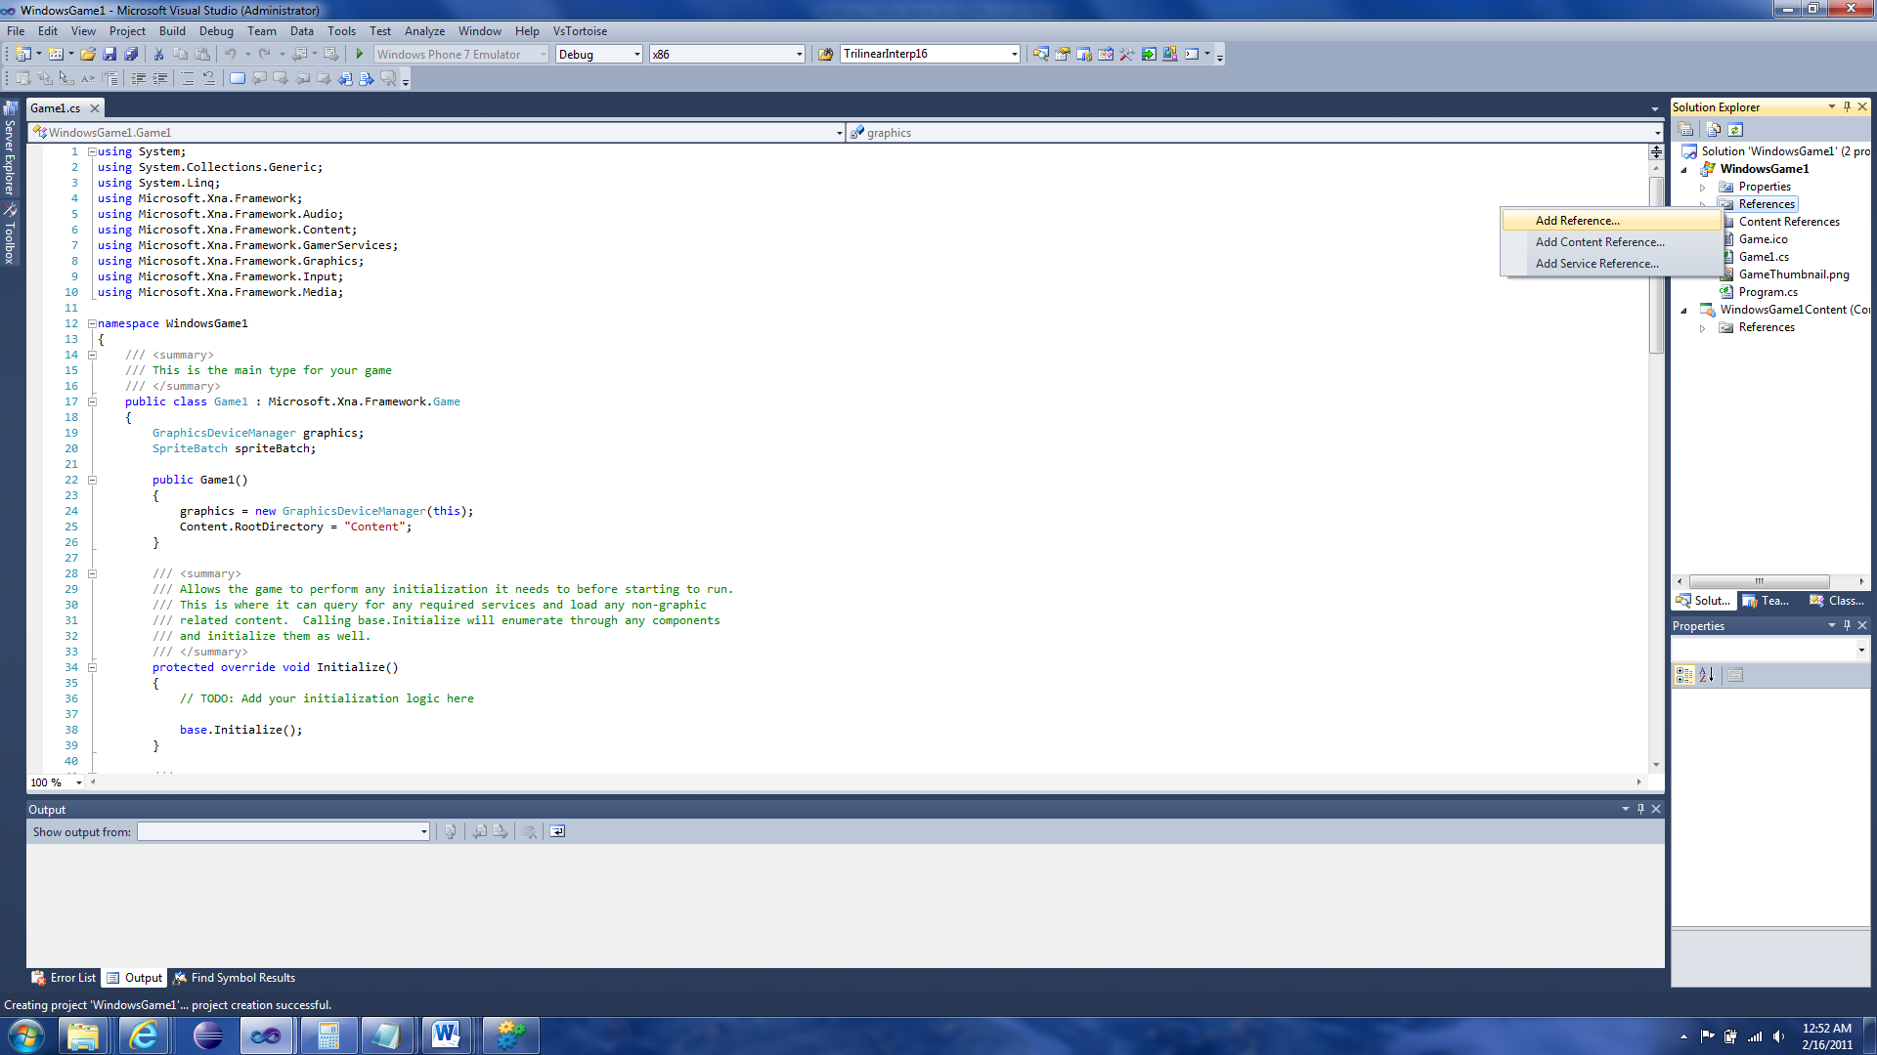

Find the SGDe.dll file in the SGDe project.

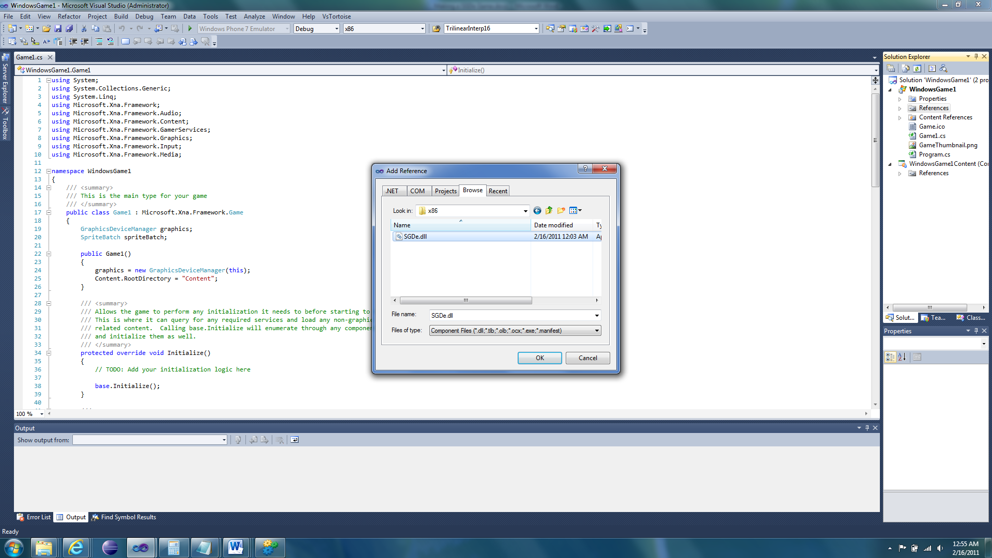

Do the same for the game’s content project. This is in the SGDeContent project.

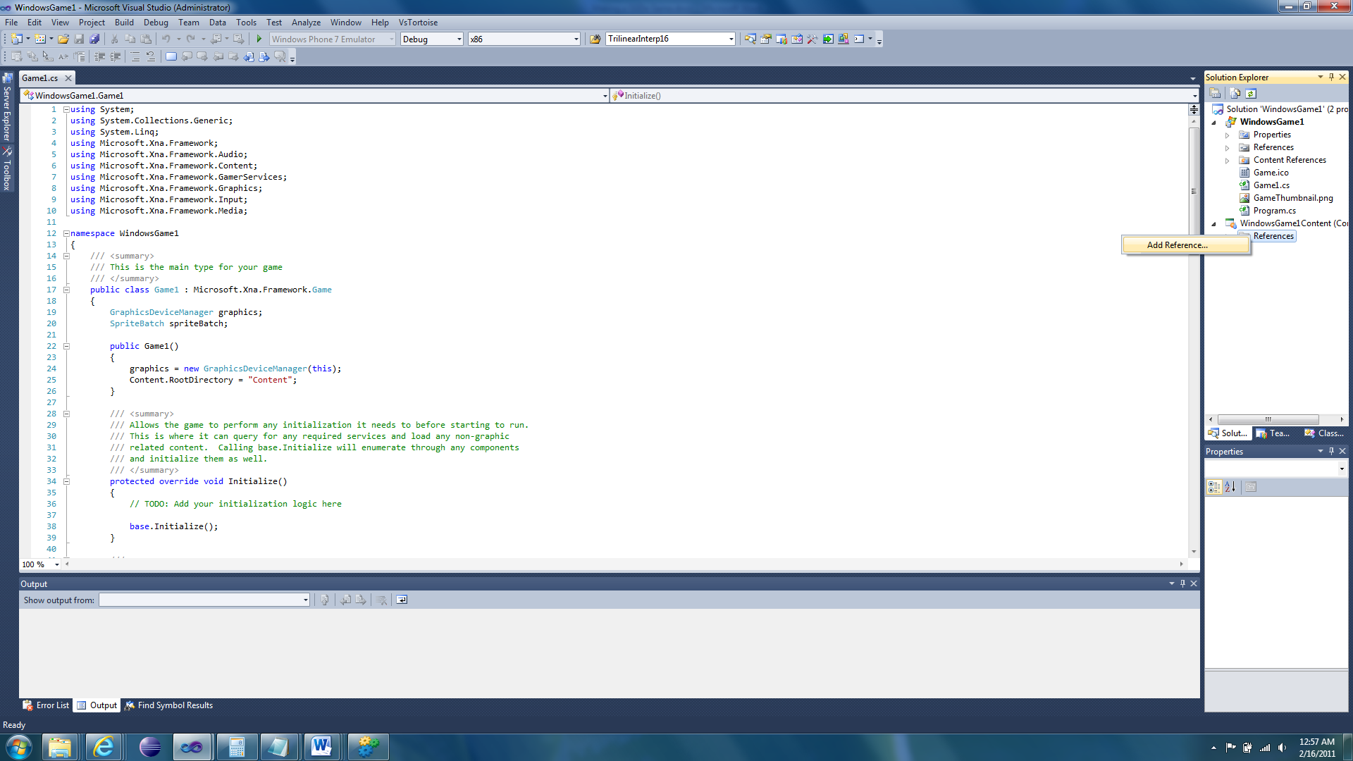

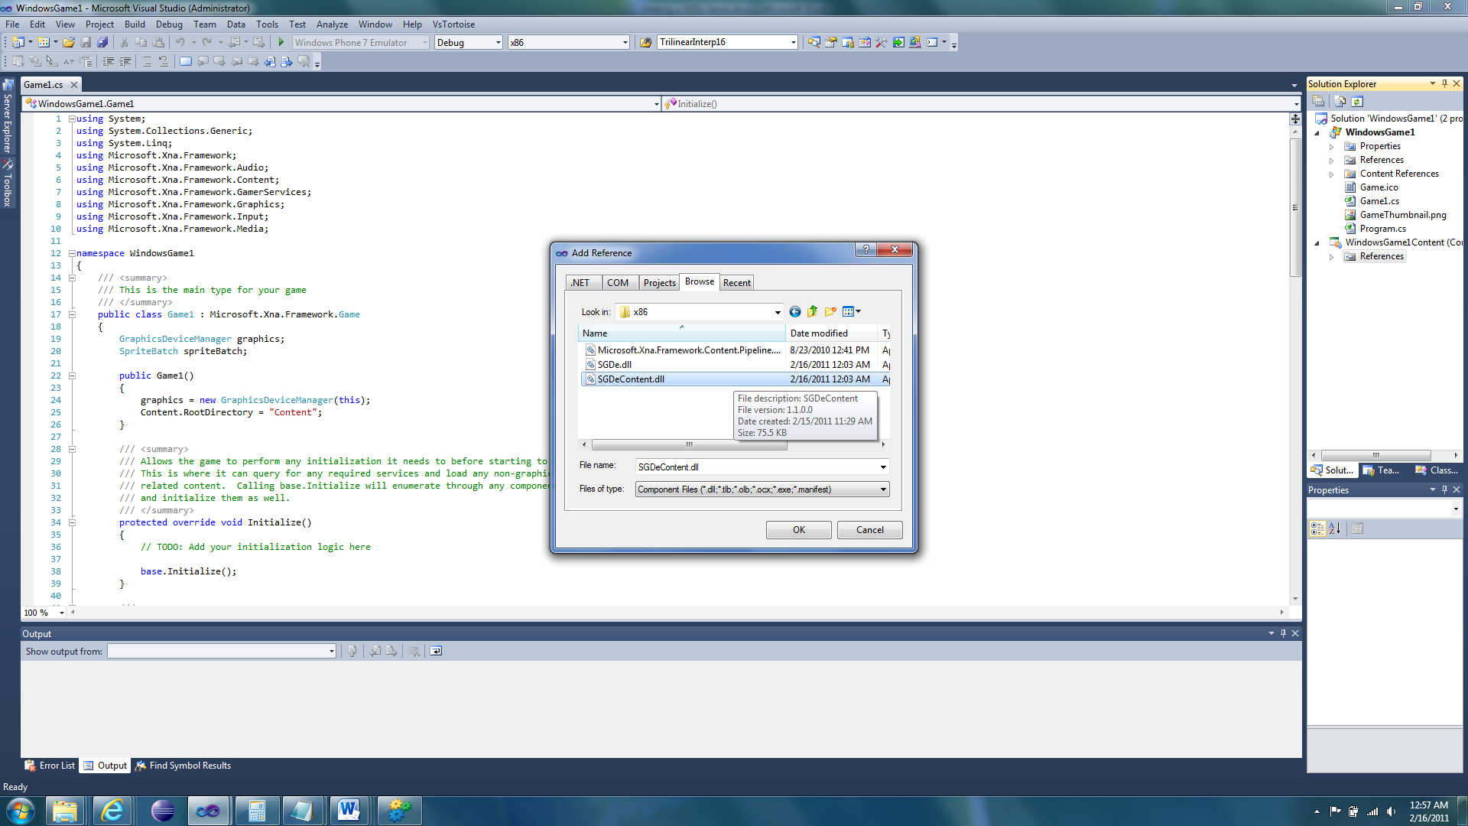

We are now ready to modify the XNA game so it is a SGDe game.

# Modifying the Game

First we simplify the code. We don’t need any of the default fields, we don’t need anything in the constructor (we don’t even need the default constructor), we don’t need the Initialize function, we don’t need anything in the LoadContent function, we don’t need the LoadContent and UnloadContent functions, and we don’t the Update function. We also don’t need the Draw function either.

Before:

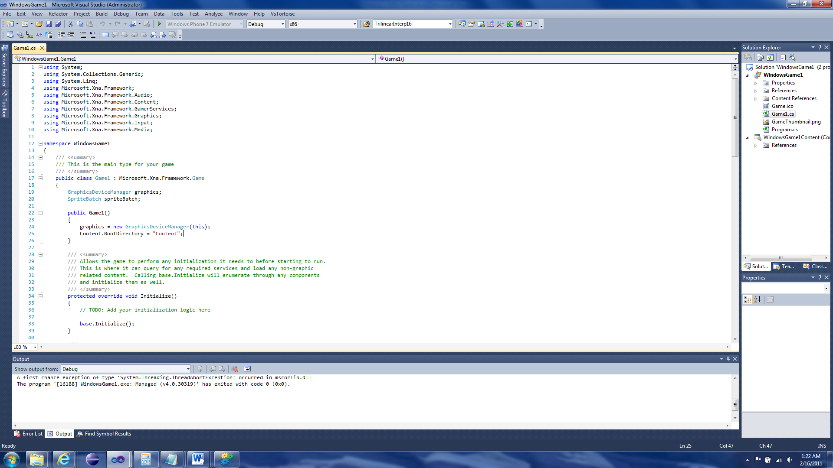

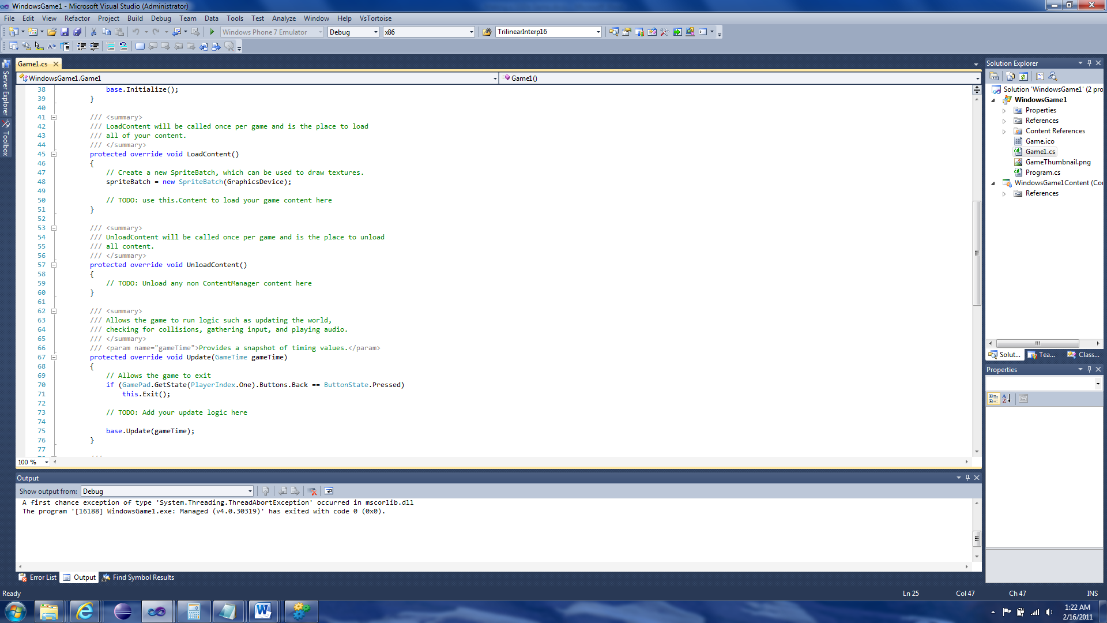

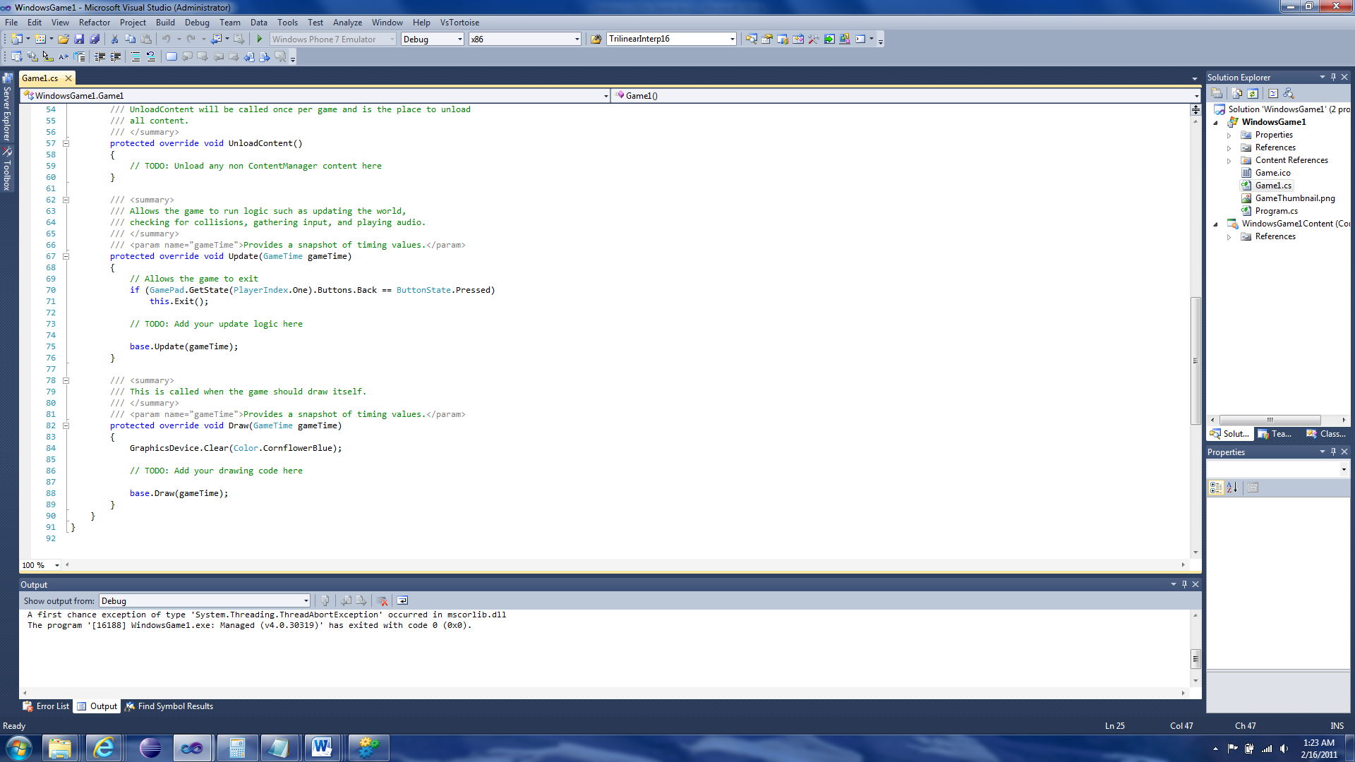

After:

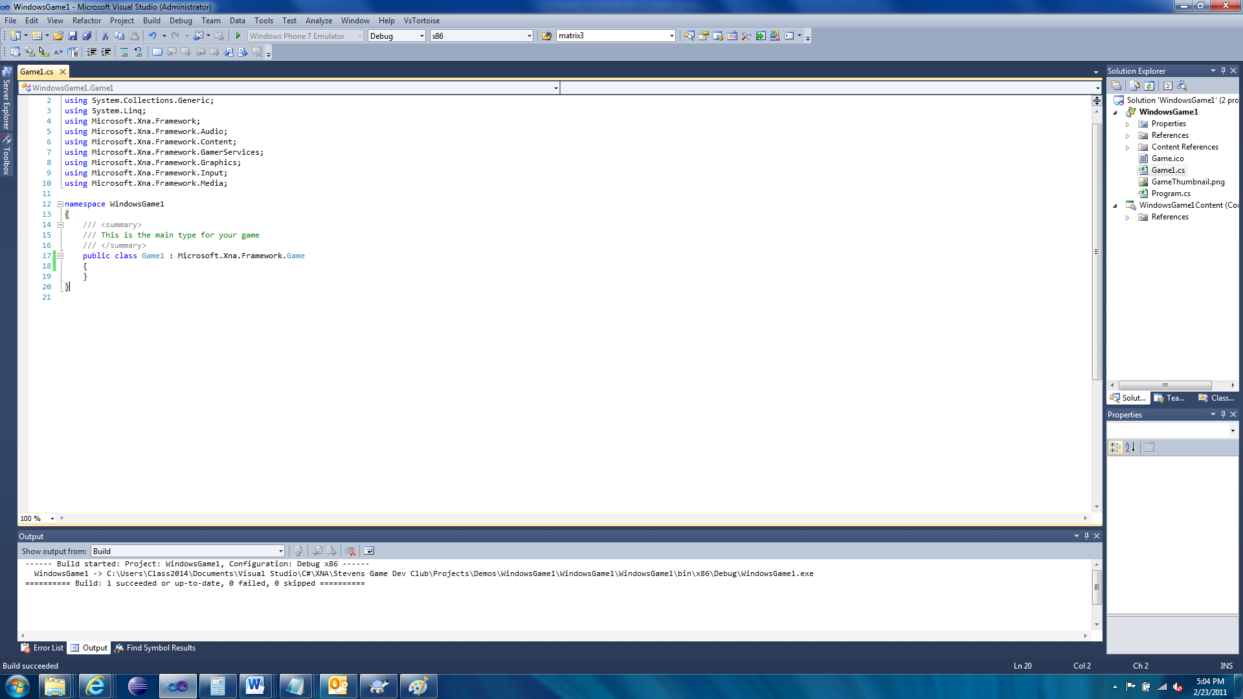

If you tried to run the game, it would crash. We have more to do!

Now we need to change the text “Microsoft.Xna.Framework.Game” at the top of the class to “SGDE.Game”.

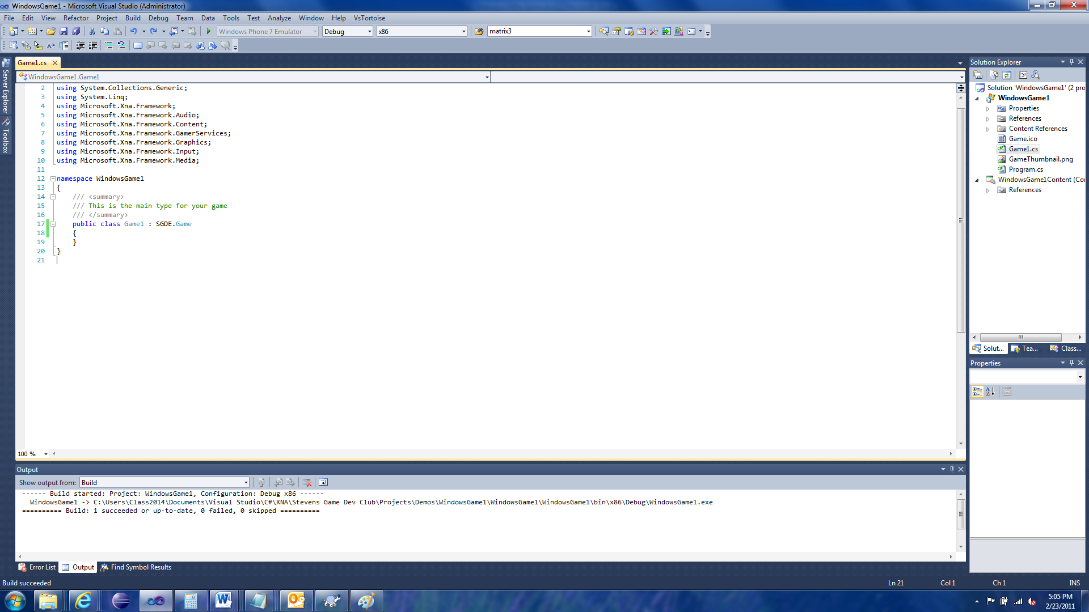

Congrats, you just made a SGDe game.

# Creating Content

To create game content we need an image, so get one.

## Game

We also need to create a game. So find your favorite text editor to do this with. If you have an XML editor then you can use that too but this tutorial only covers the text needed to be created, not the XML elements.

First save a game file with the name “Game.sgde”. The extension is important so make sure it has it.

**Note:** You don’t need to call it Game.sgde. That is the default name that SGDe looks for. If you want to use a different name then you need to set the property “GameContentName” in the game. So if you name your Game file “MyGameFile.sgde” then you need to set “GameContentName” to “MyGameFile”. Also, if you need to set this property then you need to set it before the Initialize function finishes. This means you need to set it in either your game’s constructor OR in your game’s Initialize function. If you set it anywhere else then it will be ignored and you will probably get an exception when you try to run your game.

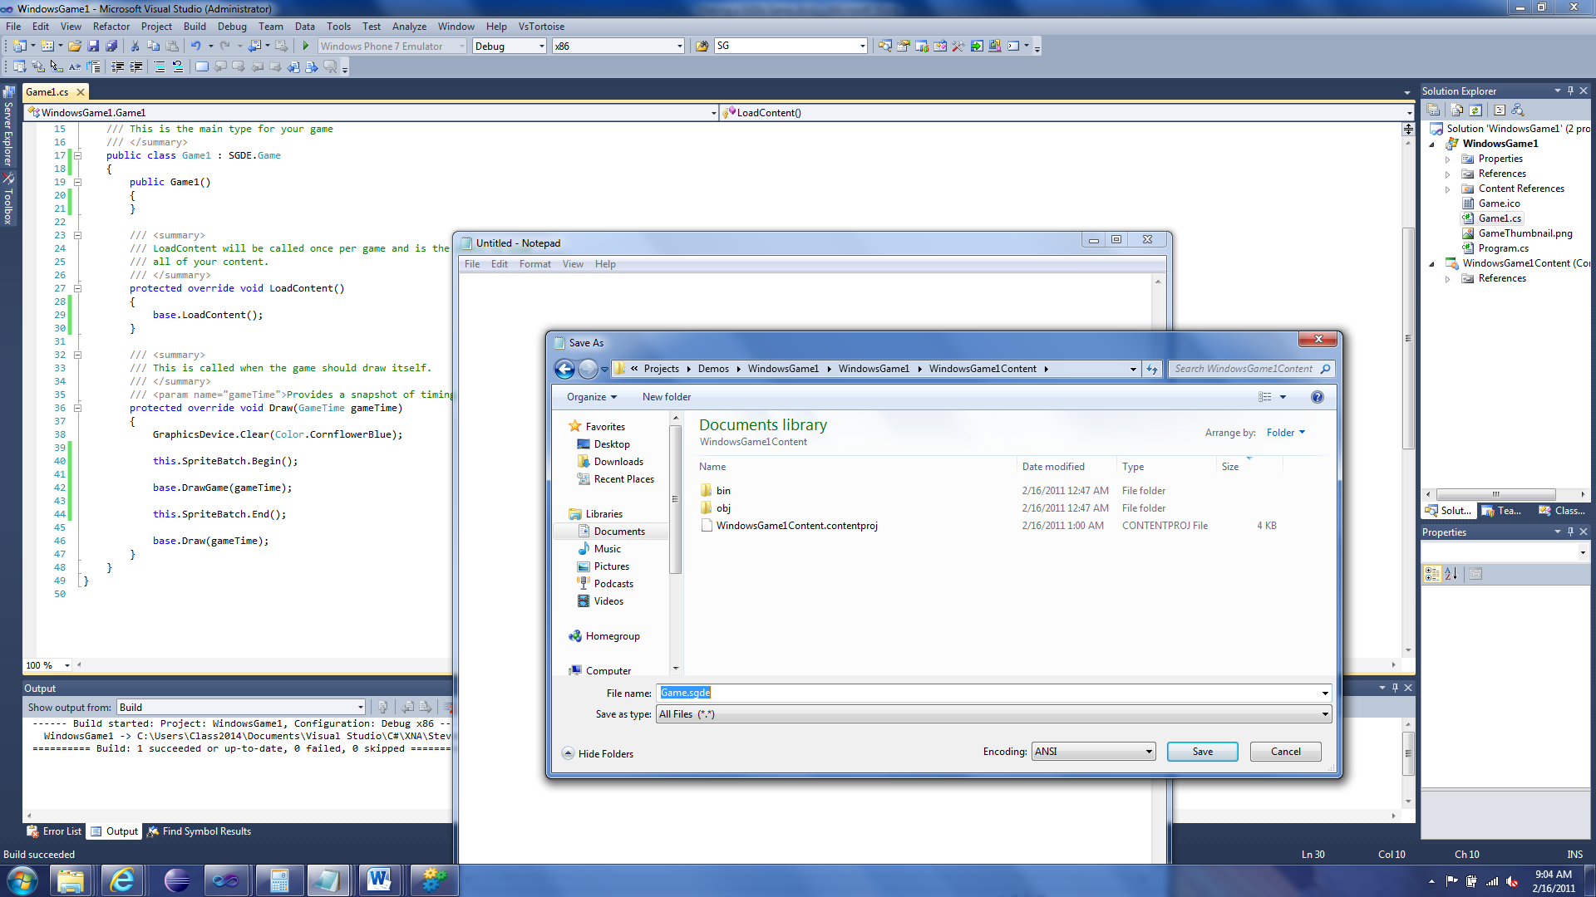

First we “should” add a declaration (for all *.sgde files. Not just the Game file):

<?xml version="1.0" encoding="utf-8"?>

Now we need to create the actual SGDE file. We create an SGDE element:

<SGDE Version=”1.1”>

</SGDE>

The “Version” attribute is very important, it tells SGDe what version content it should expect. As of the time of this writing, the newest version is 1.1.

So as of right now you should have this:

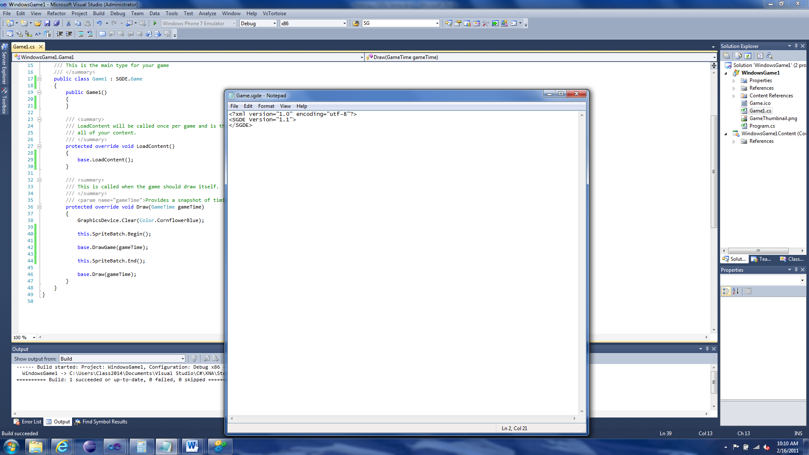

Now before we do anything else, lets add the Game file to our project.

Right-click the content project and select Add🡪Existing Item.

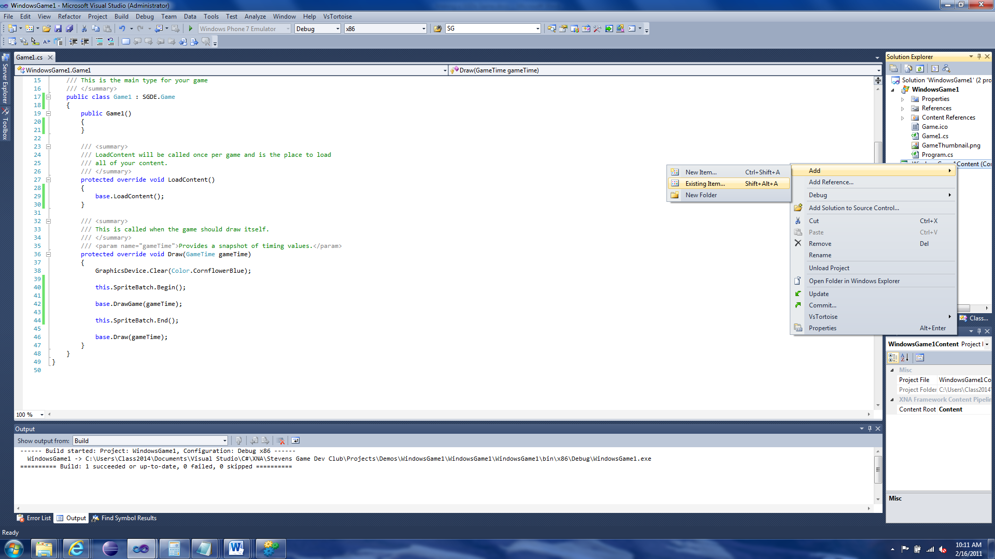

Find the Game.sgde file and click Add. If you can’t find the file you might need to change the file filter to “All Files”.

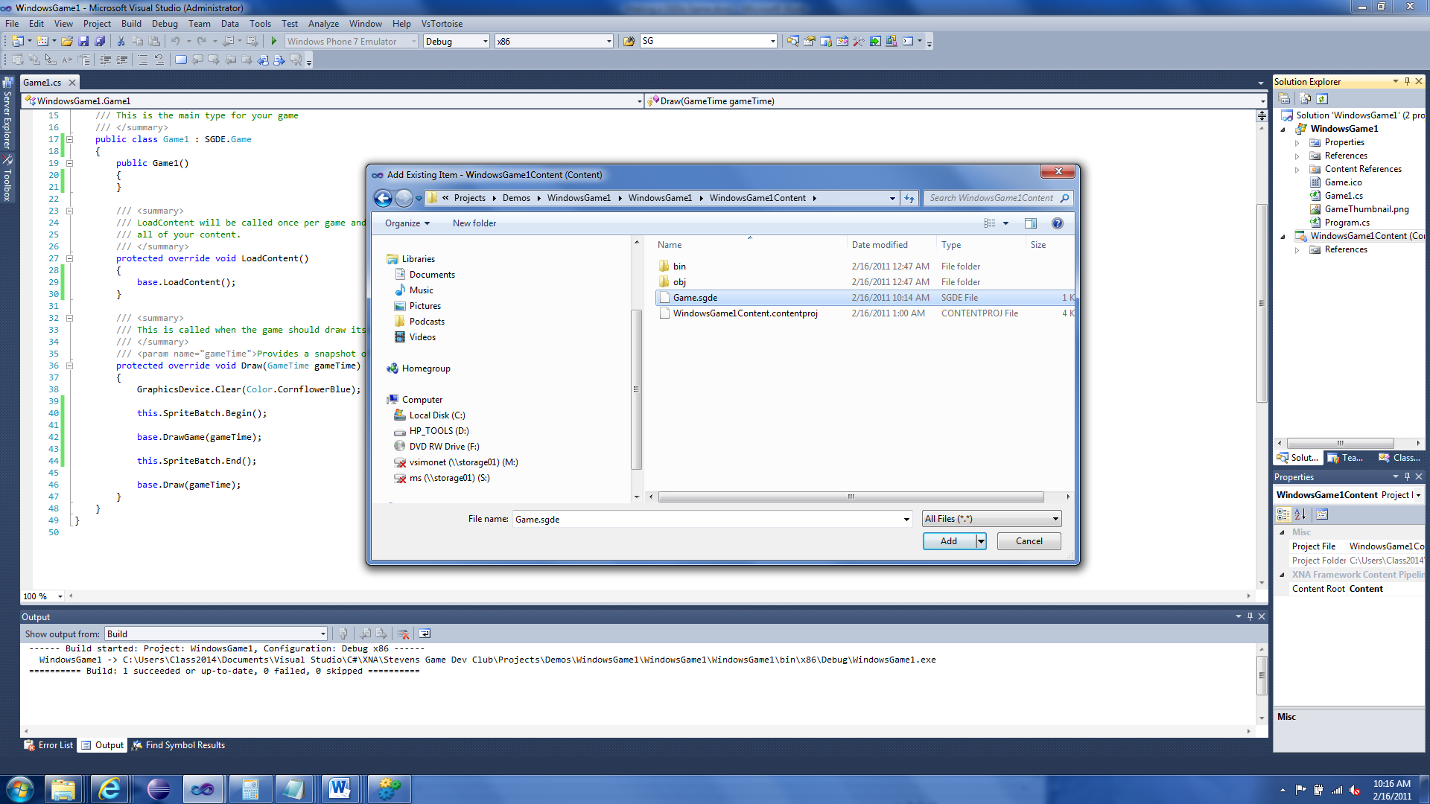

Now there is a bug that possibly occurs when you do this. It might not set the SGDE importer and processor (the components that turn the Game.sgde file into something you can use in your game). To figure this out, select the Game.sgde file in the content project and look at its properties (right-click the file and choose Properties).

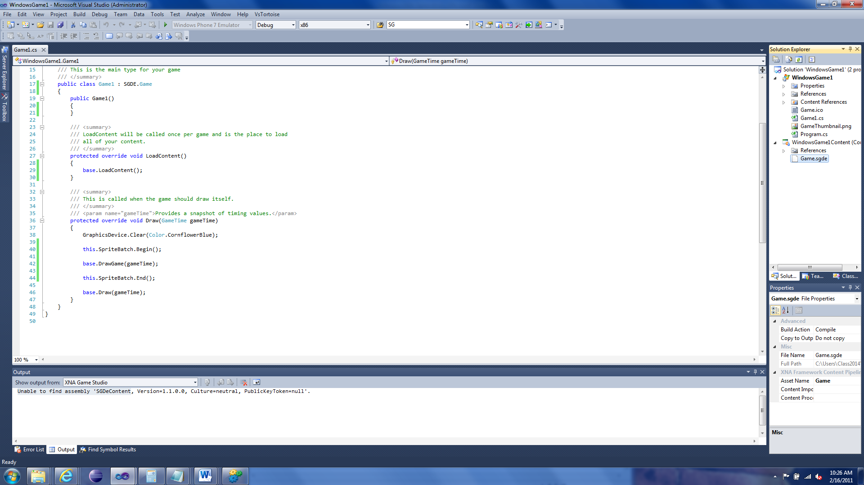

Yep, missing the Importer and Processor. If it is set (to SGDEImporter and SGDEProcessor) then you can skip the next couple steps.



In order to fix this we need to close Visual Studio. Now find the folder that the content project references. We need to find a file called {game name}Content.contentproj.

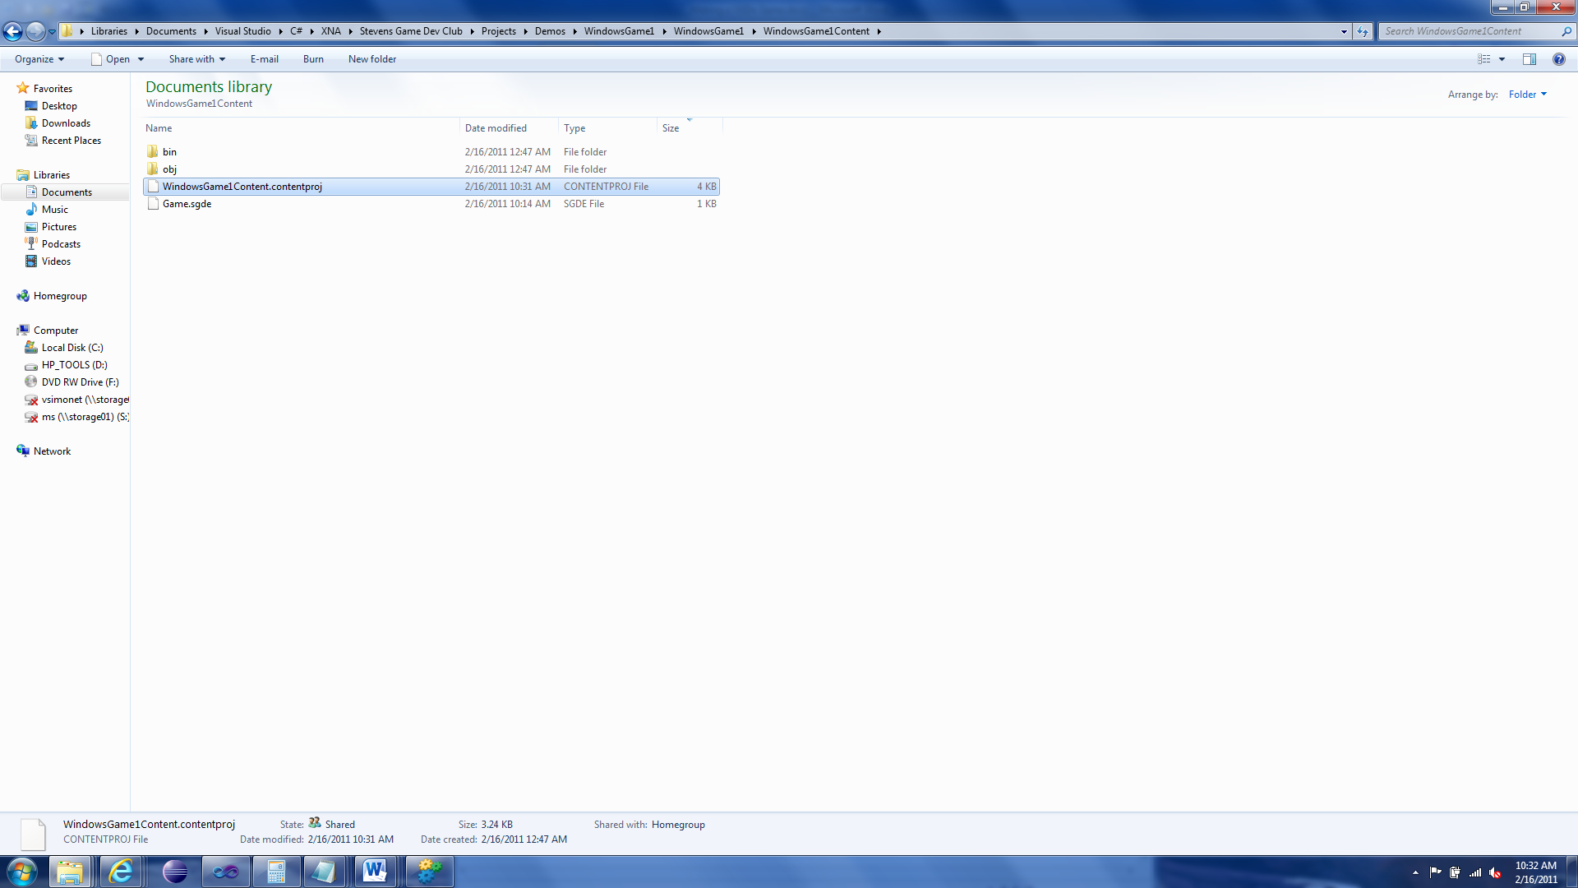

Open it with a basic text editor.

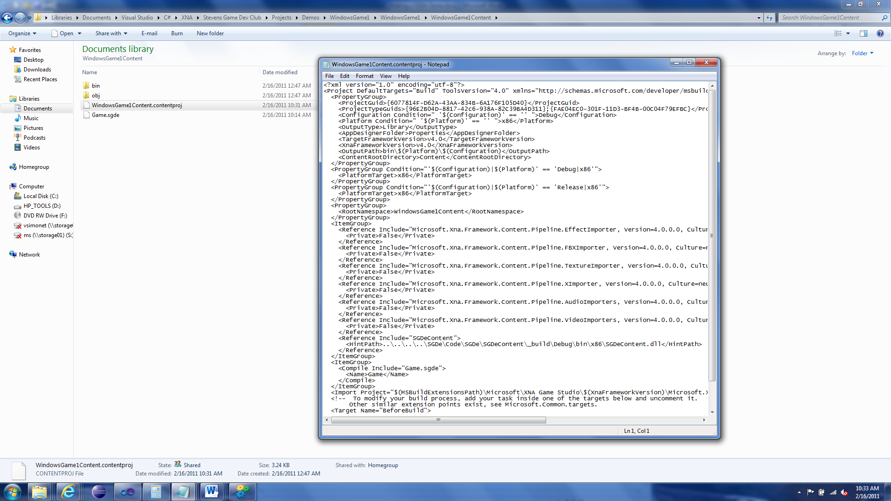

Now you might see a couple lines at the bottom of the file that contain your Game file.



We need to add two lines under the <Name> element.

<Importer>SGDEImport</Importer>

<Processor>SGDEProcessor</Processor>

These two lines add the Importer and Processor for the Game file. The content project file should now look like:

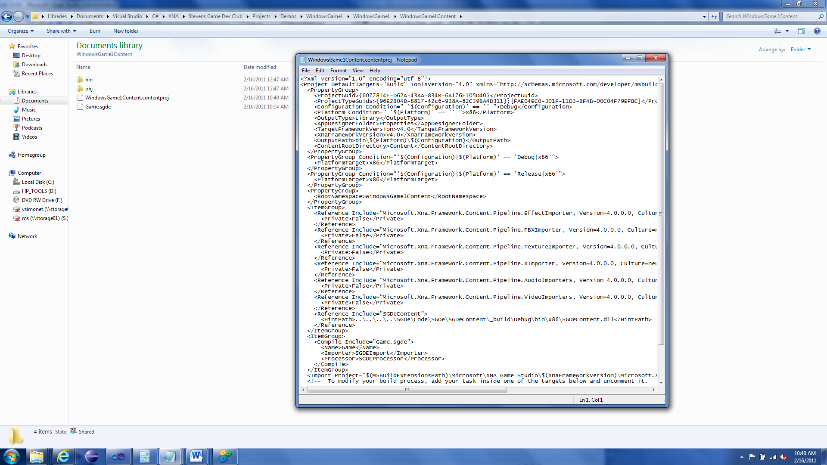

Save the file and reopen Visual Studio. Now when you look at the properties of your game file it should look like the following:

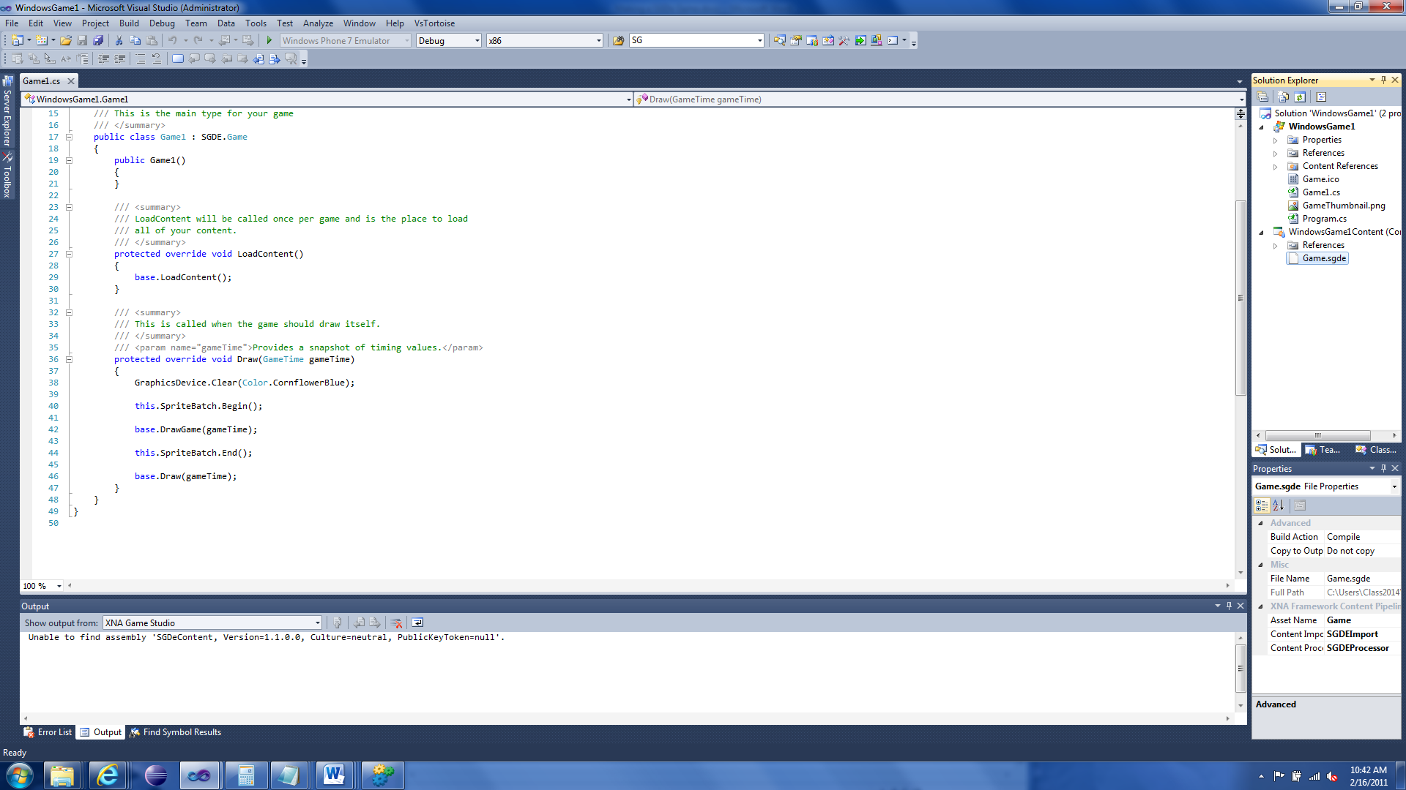

Now we can continue working on the game. We need to create two elements, <Game> and <Settings>, inside the <SGDE> element.

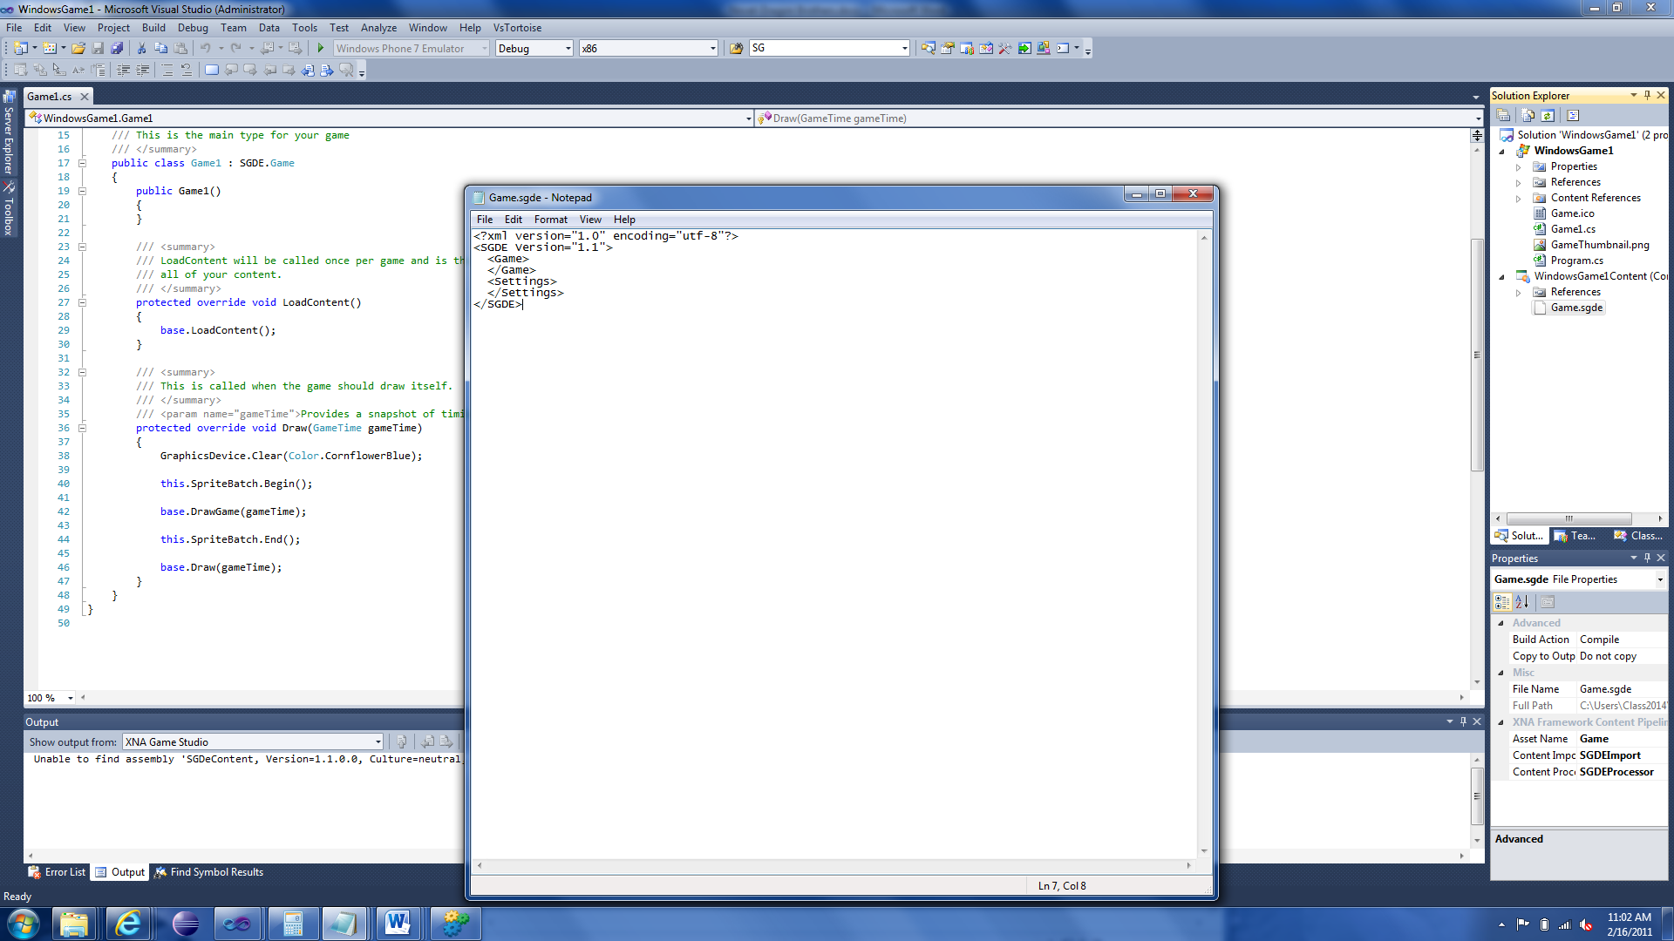

### Game

The Game element defines information for the game itself; the Settings element defines how the Game should run.

We need to create a two more components; a SpriteSheet, and Map. Both of which we will create later.

By default, a SpriteSheet is expected to be named “SpriteSheet.sgde”. If you want to use a different name then you need to specify the attribute “SpriteSheet” for the Settings element and specify the SpriteSheet file.

We need to specify the map that the Game should load. To do this we create the element <Maps> in the <Game> element.

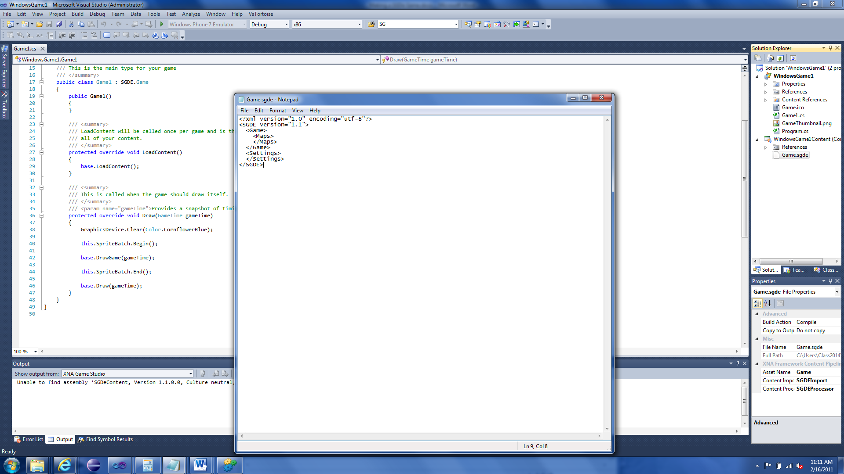

Now we specify the map to load. For this example we will call this “Map1”

<Map ID=”0”>

<Layout>Map1.sgde</Layout>

</Map>

This goes inside the <Maps> element. The ID is a positive number that will be used to identify the Map in the <Settings> element. The <Layout> element inside the <Map> element specifies the file that contains a Map.

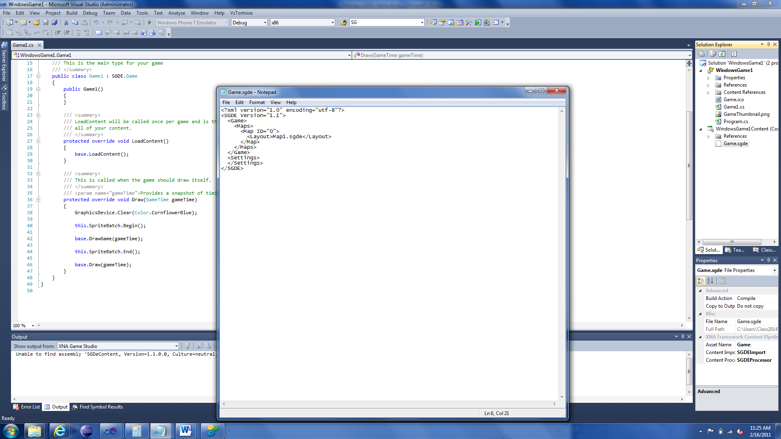

### Settings

For the <Settings> element we need to specify a <MapList> which defines how the game should run the Maps.

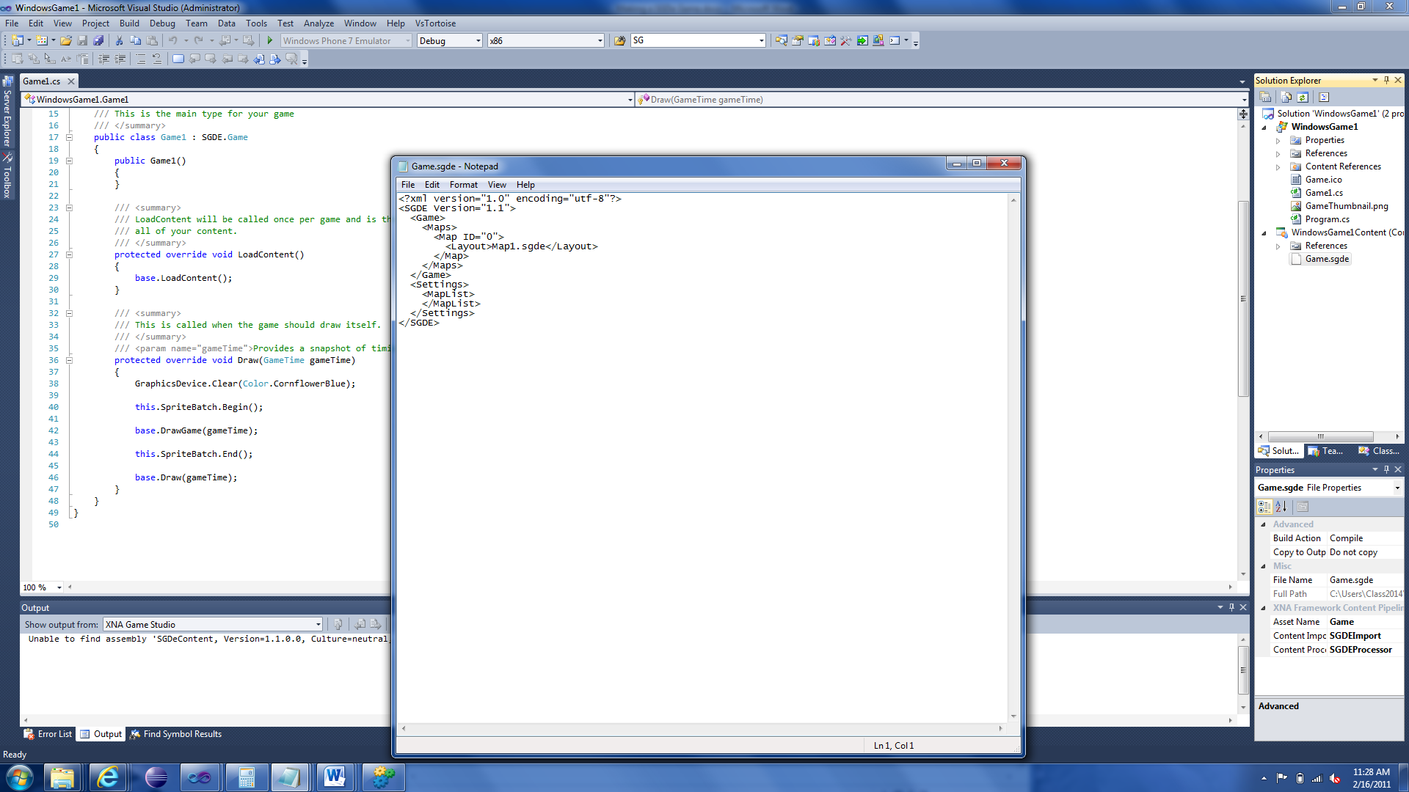

Now to specify the actual Map inside the <MapList> element:

<Map InitialMap="true" ID="0"/>

The ID references the Map from the <Maps> element we made previously. The InitialMap attribute defines if this is the first map to be loaded by the game.

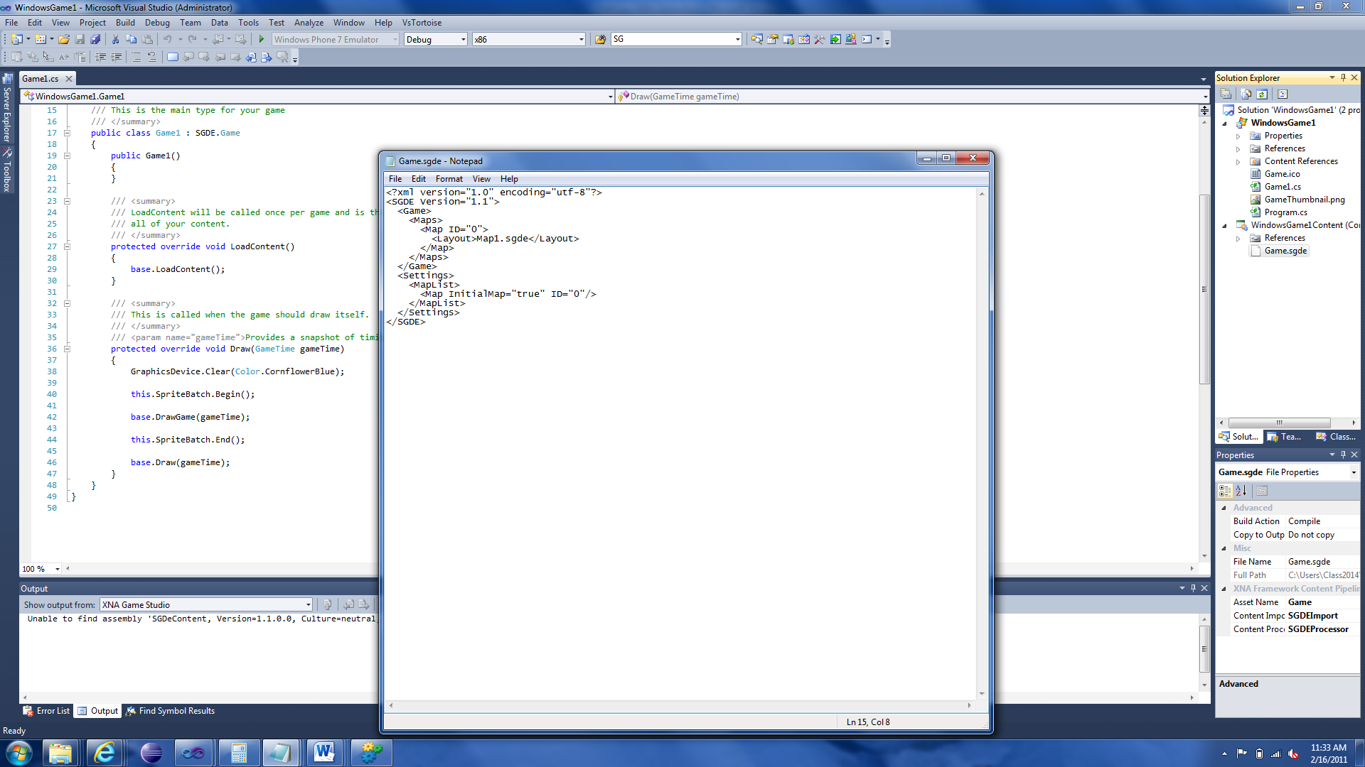

Our Game file is now done. Now let’s make the SpriteSheet.

## SpriteSheet

Now we create a new file called “SpriteSheet.sgde”. Just like with Game.sgde, add a XML declaration and SGDE element with version.

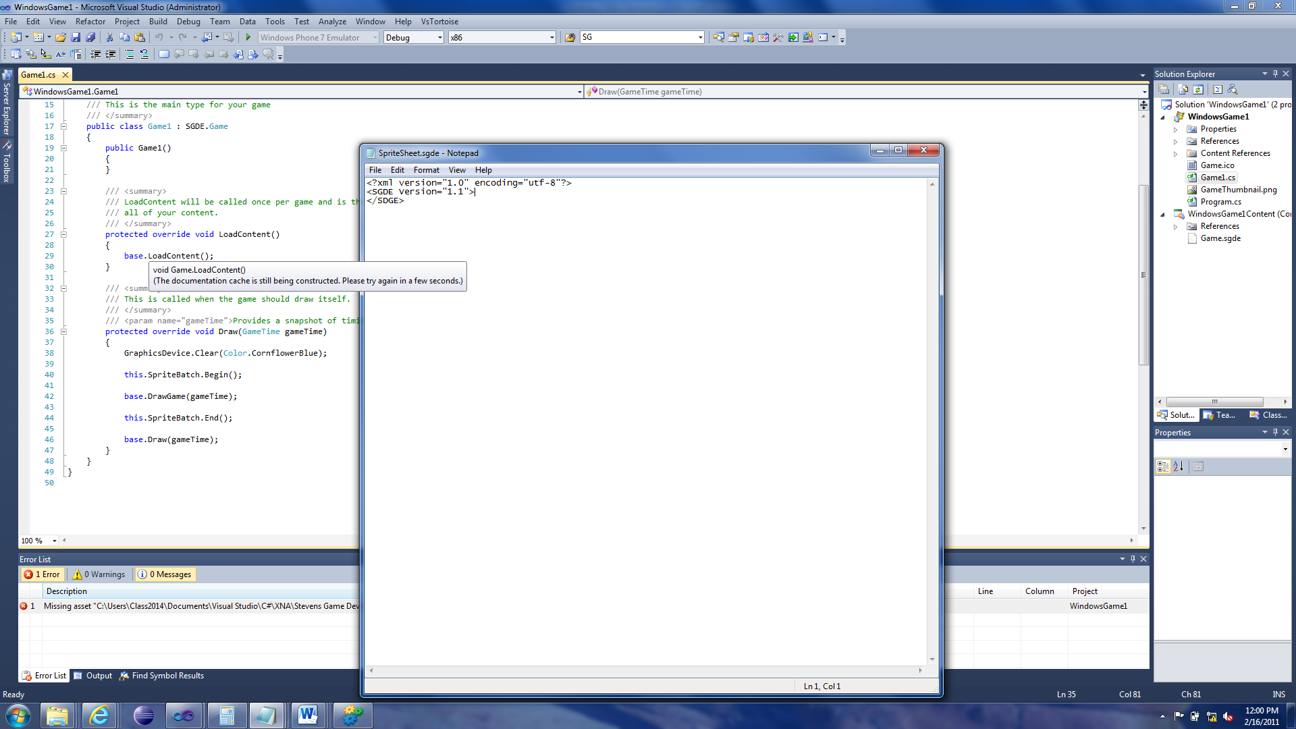

Now the first element we need is <SpriteSheets> which contains a list of SpriteSheets available for use by Entities.

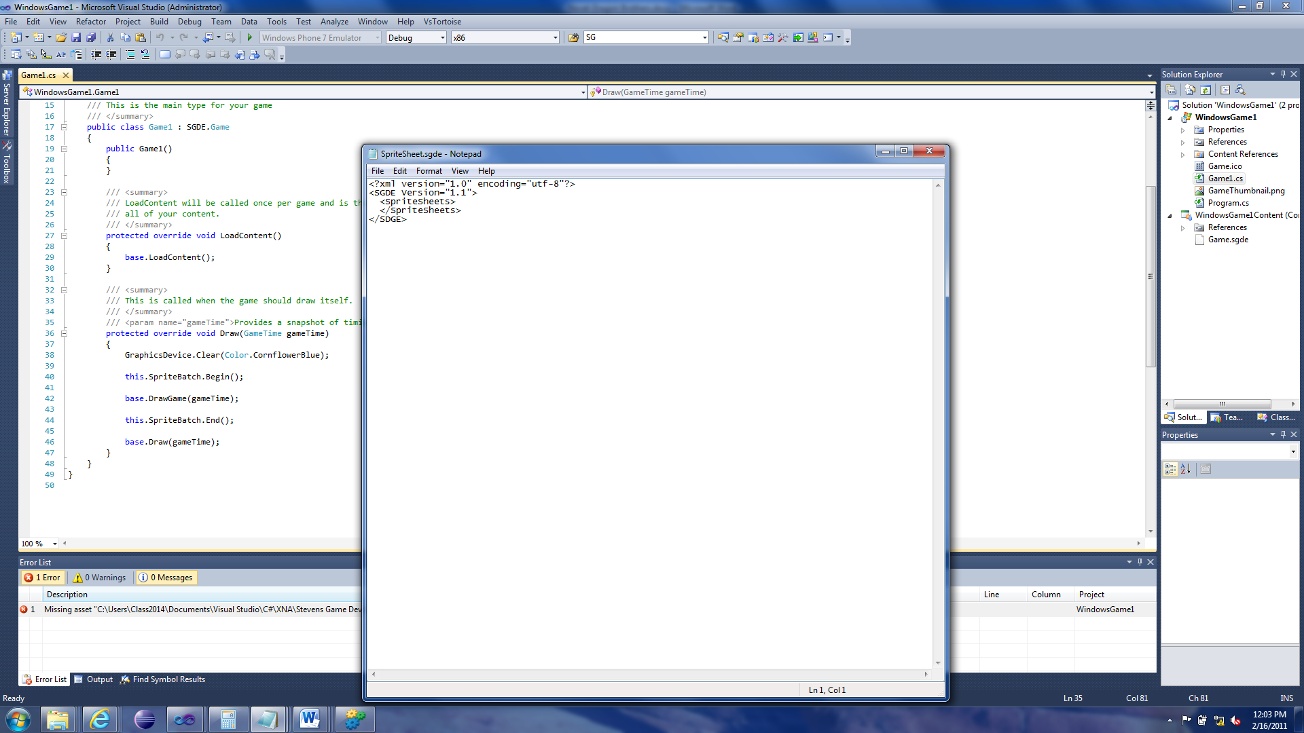

We need to add a SpriteSheet which uses an element by the same name (<SpriteSheet>). This element also needs an ID that will be referenced by Entities so they can display something.

Inside the <SpriteSheet> element, we specify a <Source> element that specifies the source of the SpriteSheet. (For this tutorial, I am using an image called “halfbaked.jpg”).

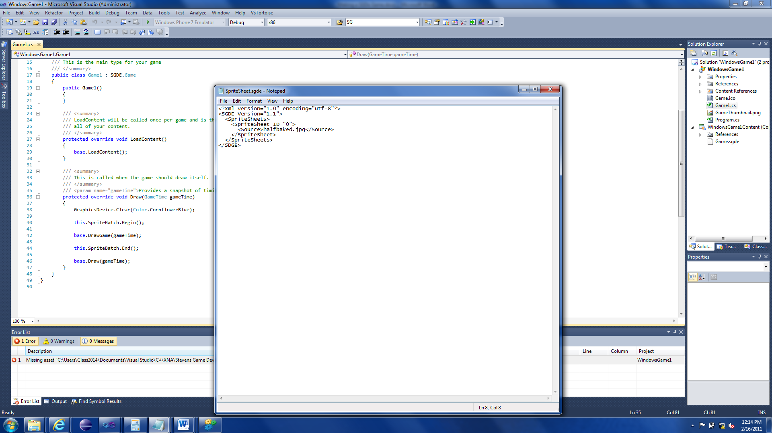

Now SpriteSheet is done. On to the final component, the Map.

## Map

Now we create a new file called “Map1.sgde”. Just like with Game.sgde and SpriteSheet.sgde, add a XML declaration and SGDE element with version.

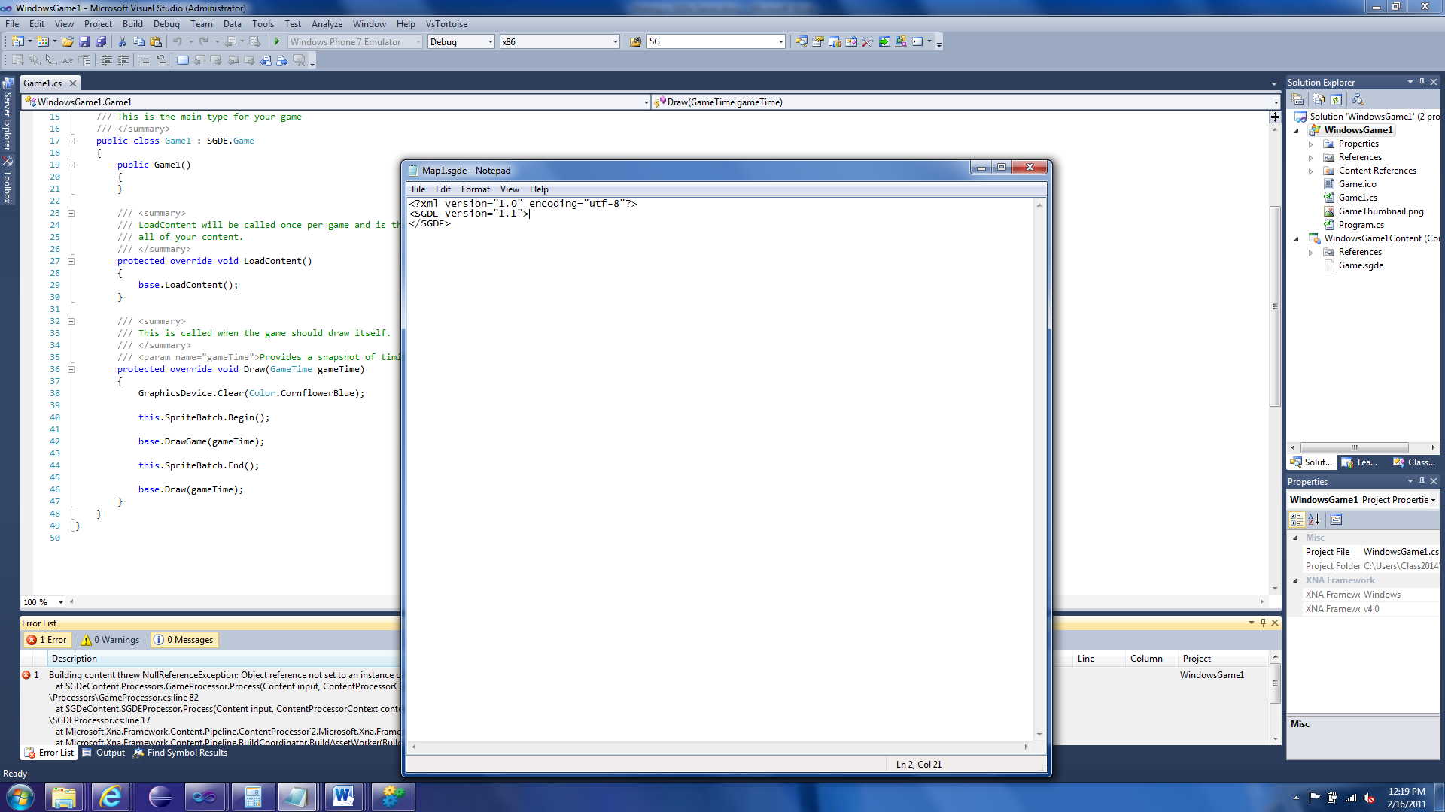

This is probably the most complex portion of the entire content system so follow closely.

First we need to make two new elements inside the <SGDE> element; <Map> and <Resources>.

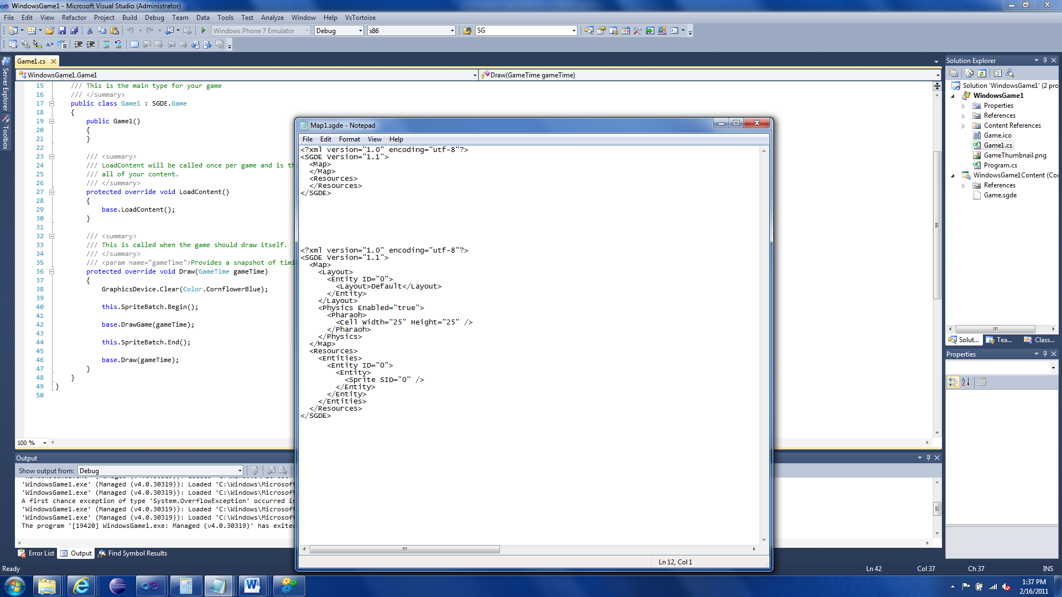

### Map

The map element defines the map and how it should be laid out.

It is comprised of two elements, <Layout> element and <Physics> element.

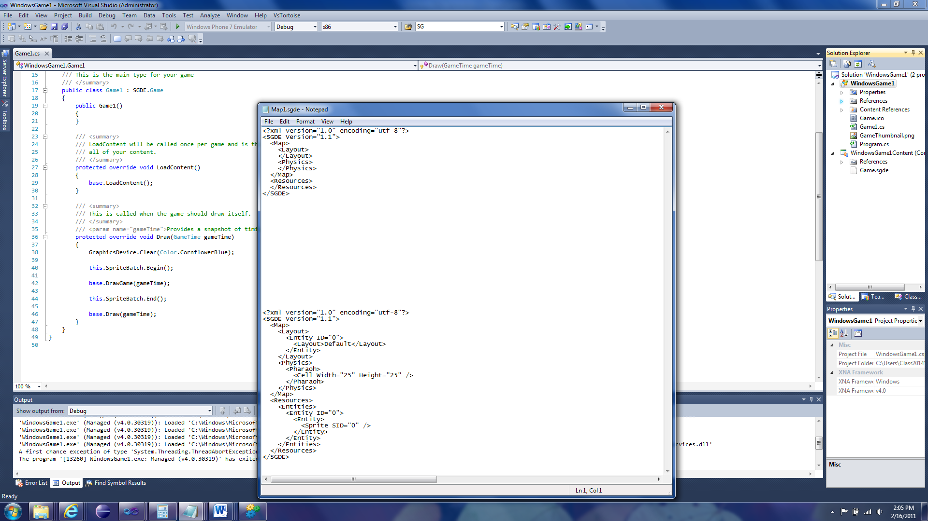

#### Layout

The layout element defines how the map should be laid out.

We need to add an <Entity> to the Layout to display:

<Entity ID=”0”>

<Layout>Default</Layout>

</Entity>

The ID references what Entity is being used (from the Resources element). Inside the <Entity> element is a <Layout> element (not related to this Layout element). This is used to determine how the Entity should be laid out on the map.

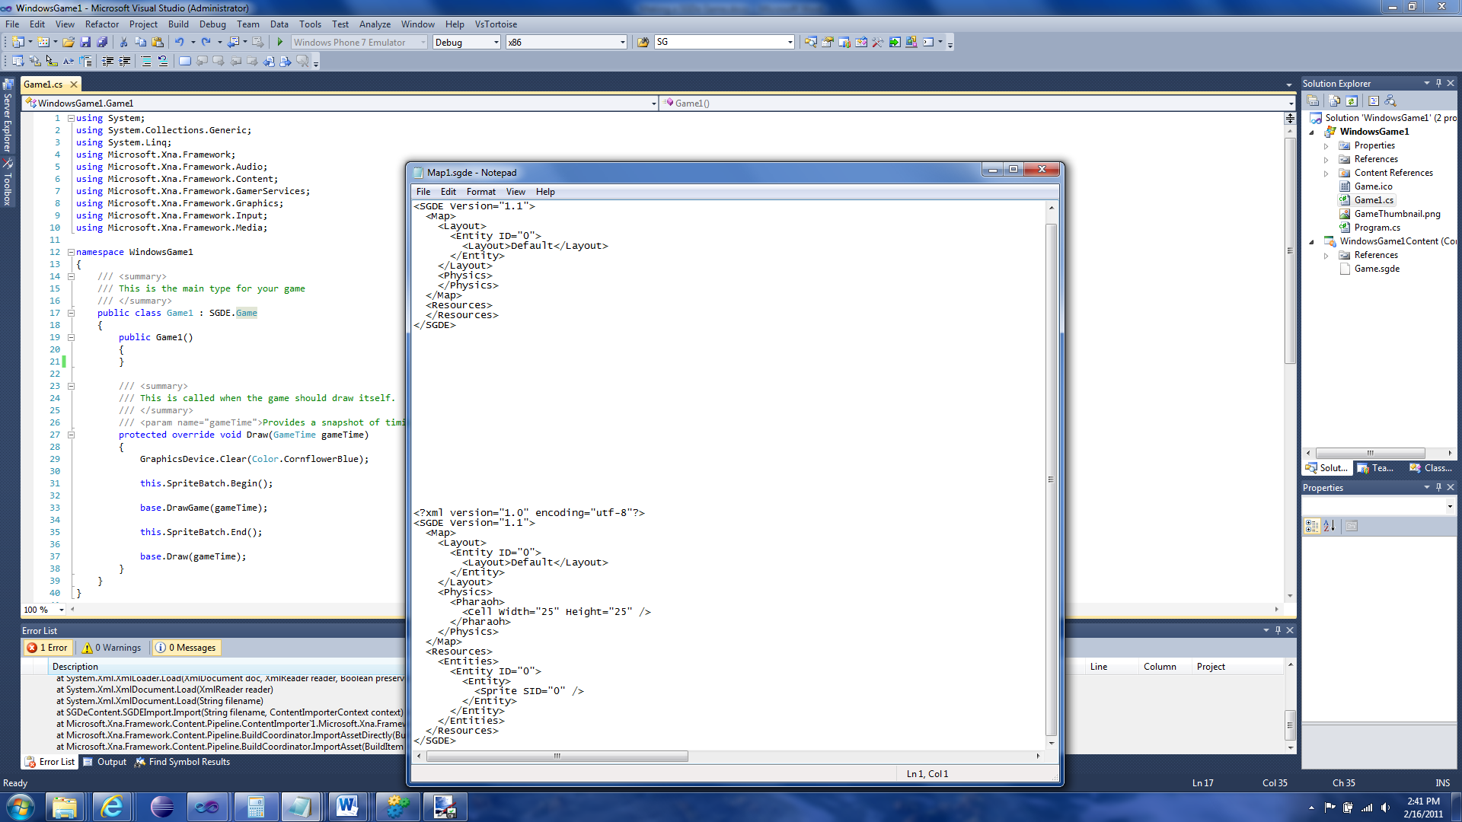

#### Physics

The Physics element defines the physics for the map. For the purposes of this tutorial, we don’t need physics. But the game won’t run without a having it’s “physics grid” defined. So to do this we need to define the element <Pharaoh>. Pharaoh is the central component that manages the whole physics system.

Inside the Pharaoh element we need an element called <Cell> which defines the size of a physics cell. Physics is processed per cell so for more accurate physics you use a smaller cell size; less accurate, bigger cell size. For this tutorial I defined the cell size as 25x25.

<Pharaoh>

<Cell Width="25" Height="25" />

</Pharaoh>

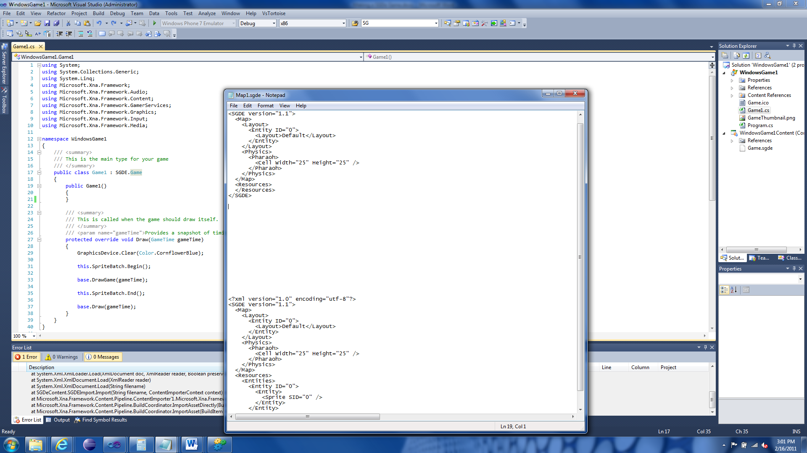

### Resources

The Resources entity defines the resources used by the Map.

The primary component is the <Entities> element, which defines the Entities used for the Map.

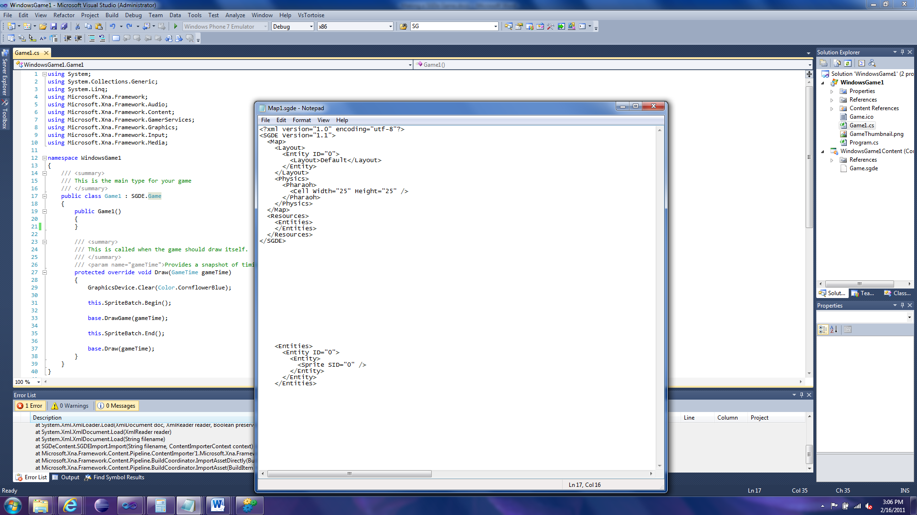

Now this will seem redundant but just follow along. We need to create an <Entity> element. This should contain an ID which will be referenced by the Entities in Layout.

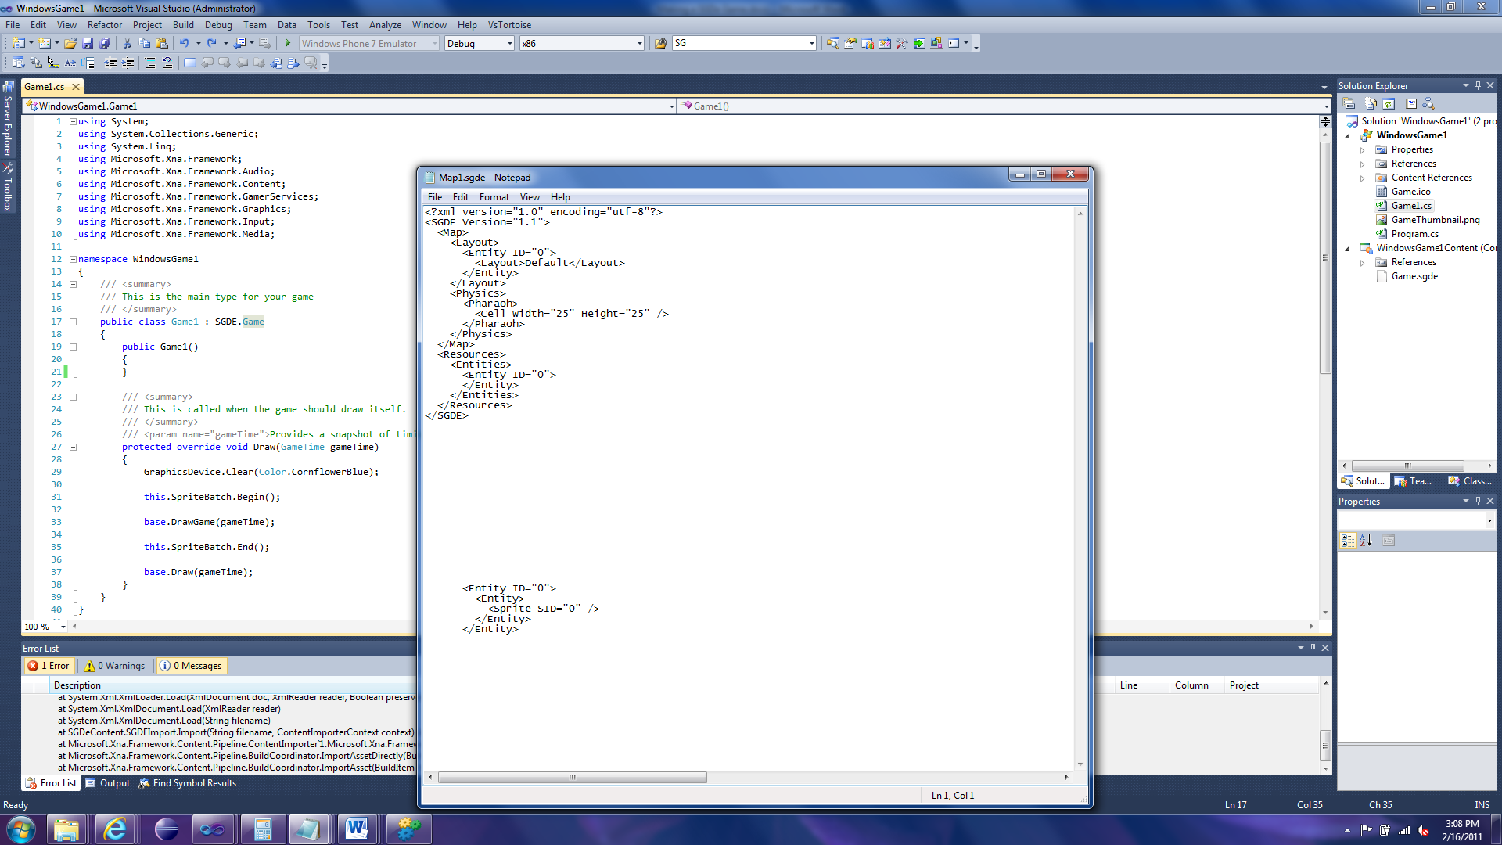

Now we need to define the Entity itself, so create another <Entity> element, this time without an ID. This time we are defining an actual Entity, but for the this tutorial you just need to define the Sprite it uses:

<Entity>

<Sprite SID="0" />

<Entity>

The SID in Sprite references the ID from the SpriteSheet file.

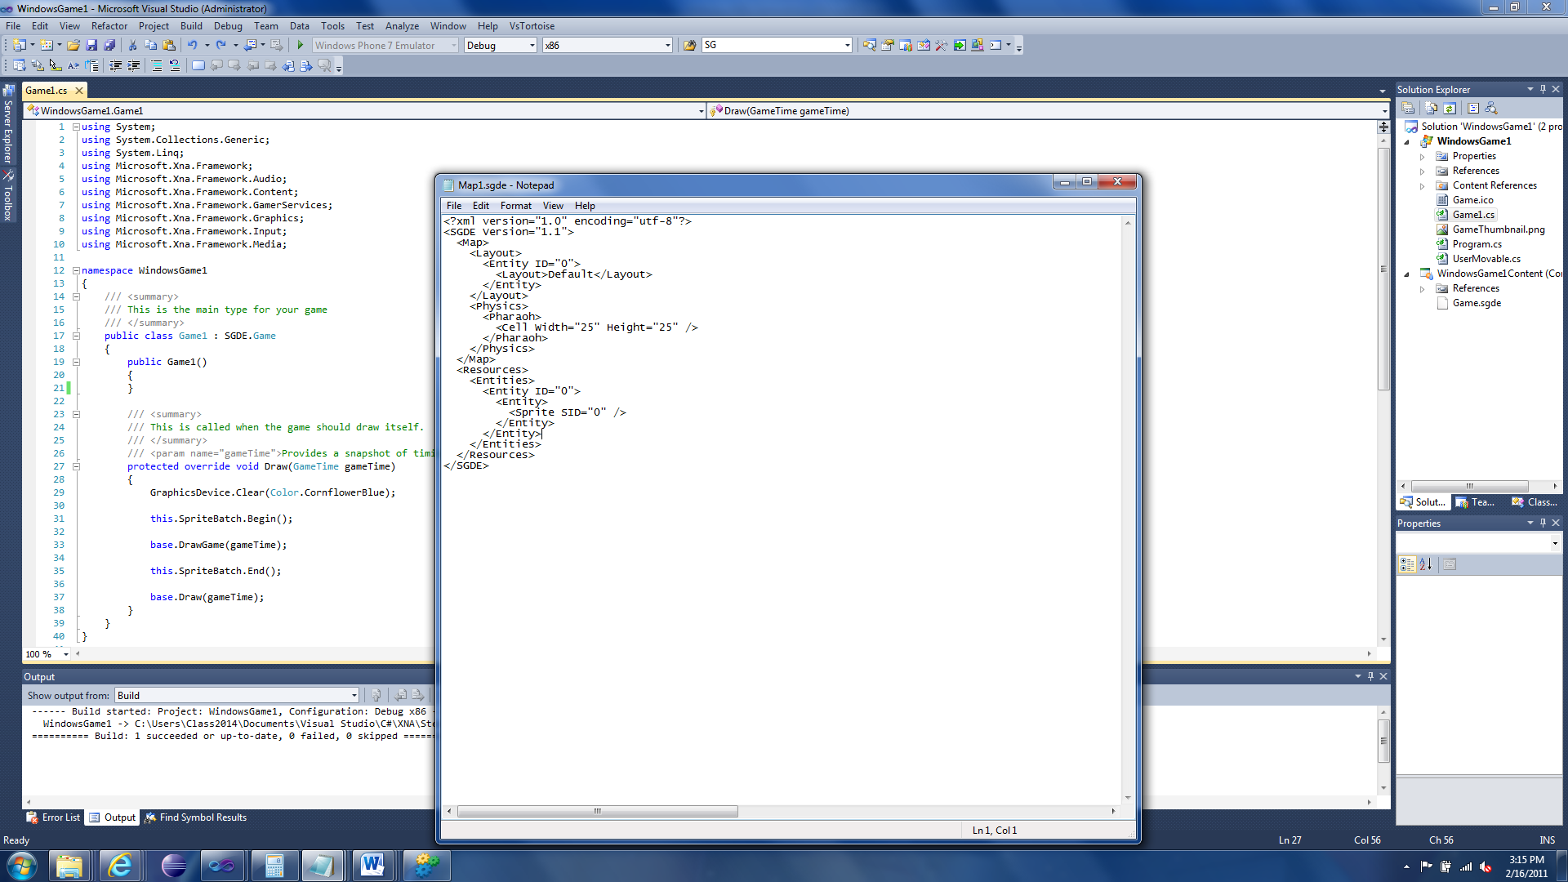

That’s it. You should now have a working game… well not really a game. But you now have a SGDe game template that you can build off of.

For more information on the format of SGDe content, read the “Content Format” document in the Documentation folder, under SGDe.

# BONUS!!: User interaction

So can we move our little Sprite around? Yes, and easily too. Well not too easily but easy enough.

First open our map file, find the actual Entity definition in the Resources element. Under the Sprite element add:

<CustomEntity Base="SGDE.Entity, SGDe">WindowsGame1.UserMovable, WindowsGame1</CustomEntity>

This tells the Program that we want it to use a specific Entity type, in this case, a UserMovable component in the game WindowsGame1. For more information about this format read the Content Format document.

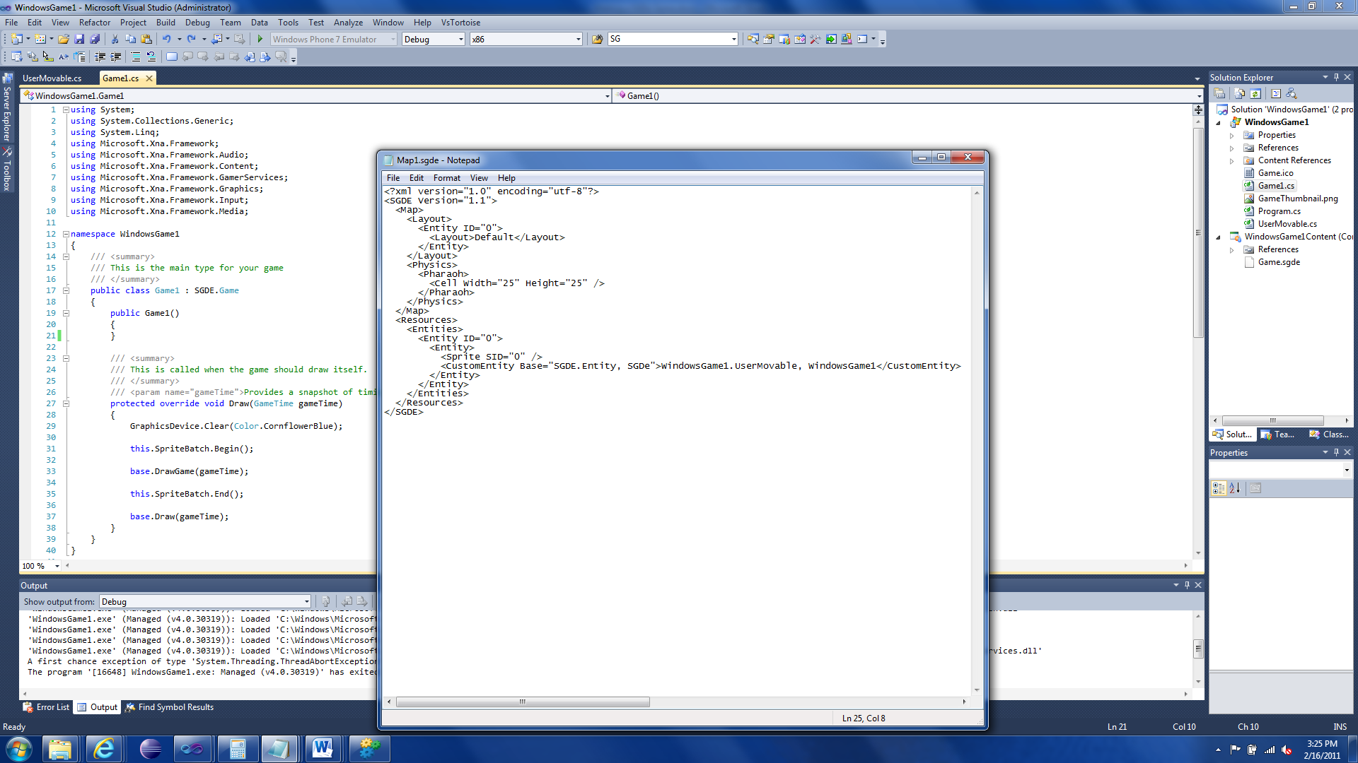

If you try to run the game… it crashes.

Now we need to make the “UserMovable” class.

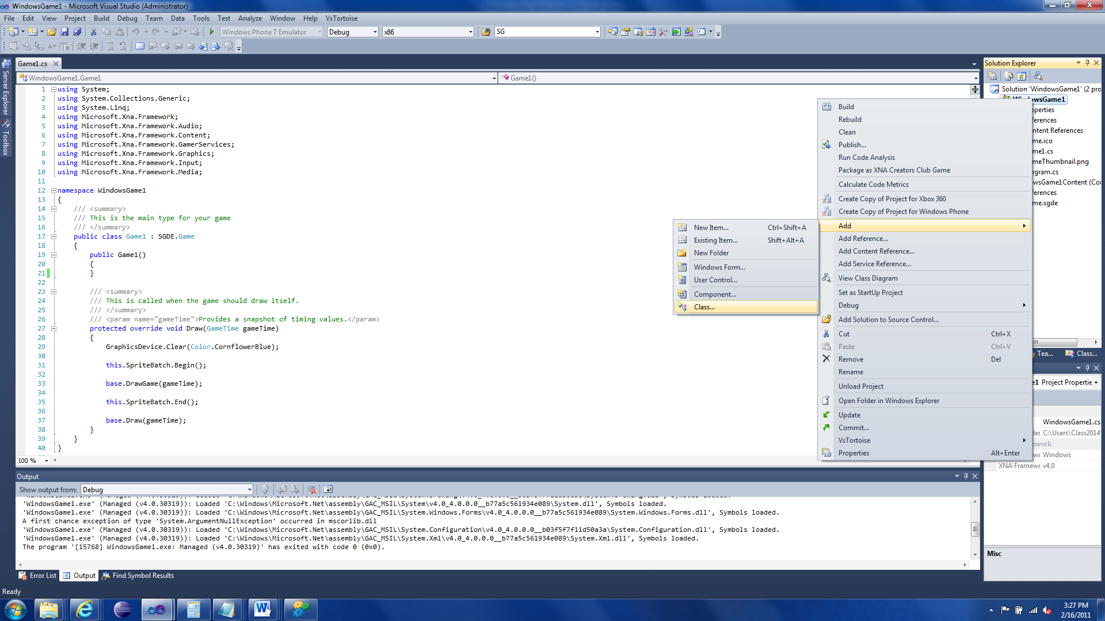

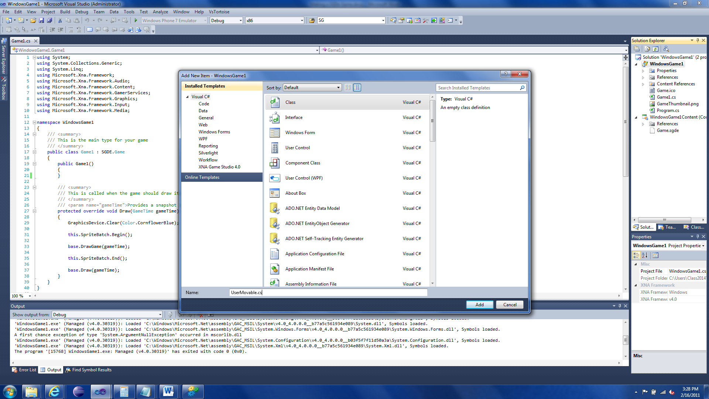

Click Add to create the new class.

Add a “public” modifier to class and the following line after the name “: Entity, InputHandler”.

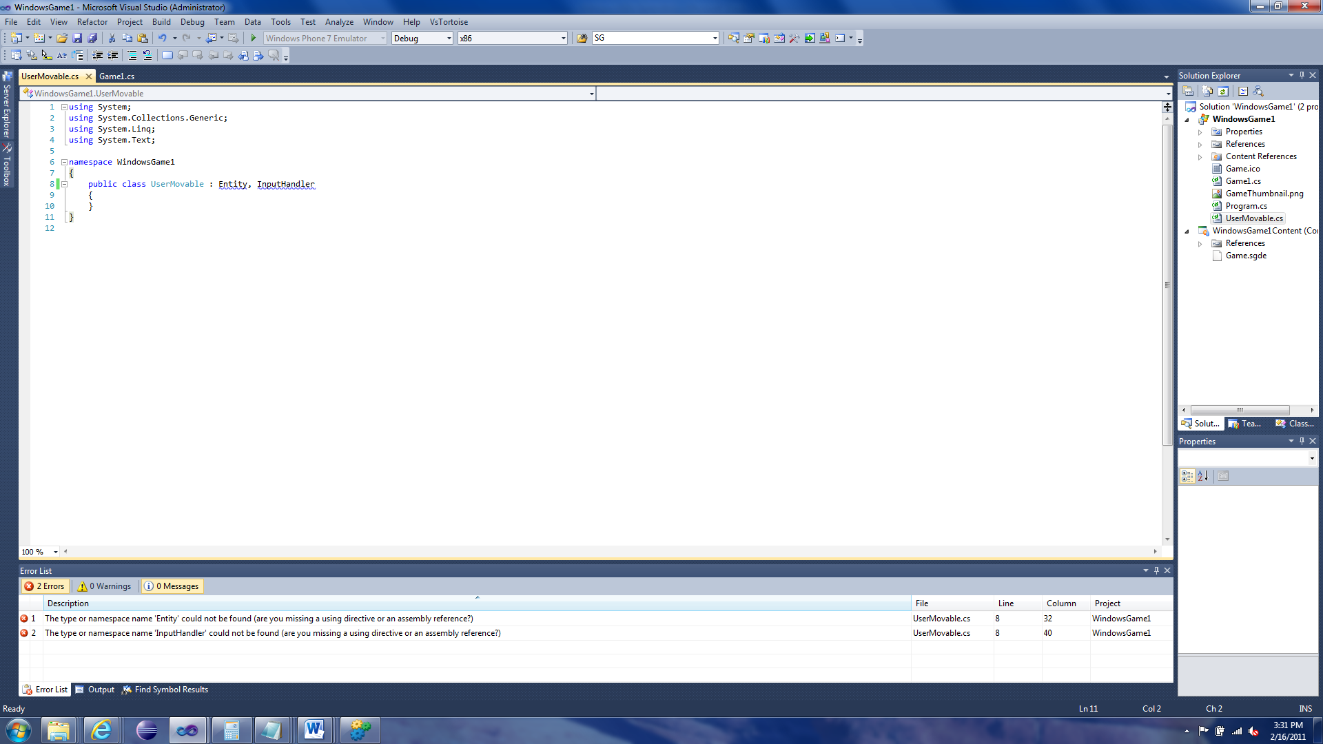

The class is now based off a SGDe Entity and can handle input. But if you try to compile it, it gives you errors. We need to implement the InputHandler interface.

Click over “Entity”. A really small box should appear under the first letter. Put your mouse over it and an arrow should appear. Click it to get a dropdown menu. Select “using SGDE;”

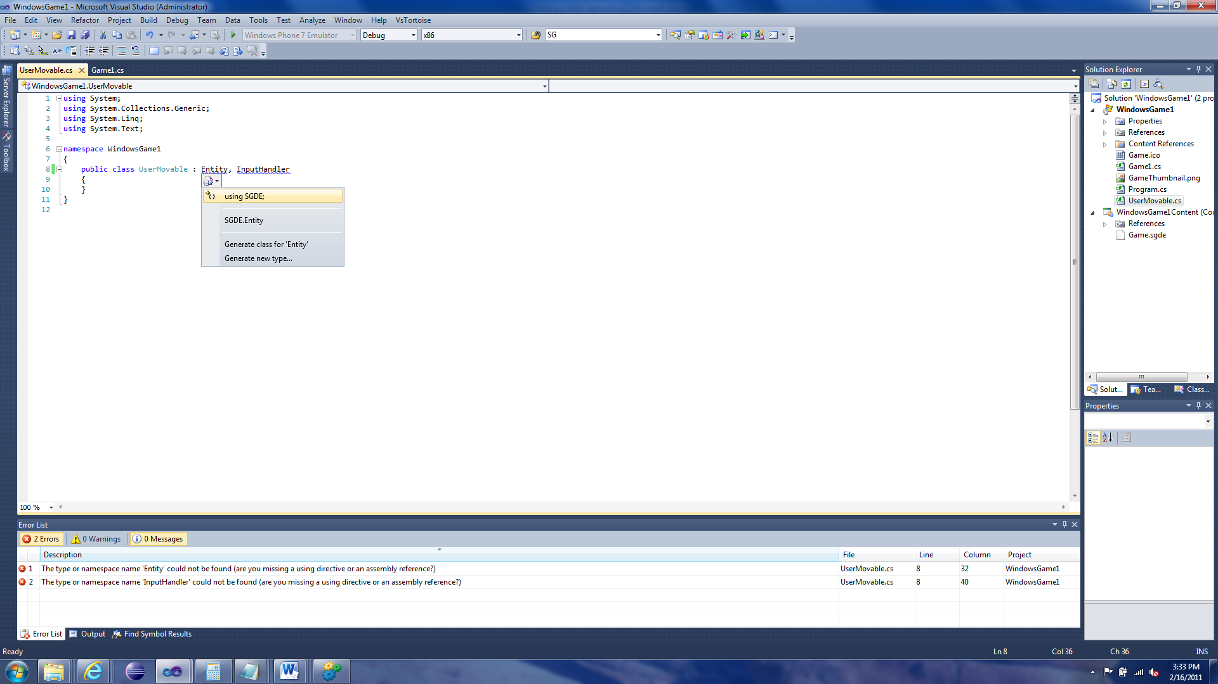

Do the same for InputHandler but with “using SGDE.Input;”. Now the box still exists if you click InputHandler again. This time choose “Implement interface ‘InputHandler’”.

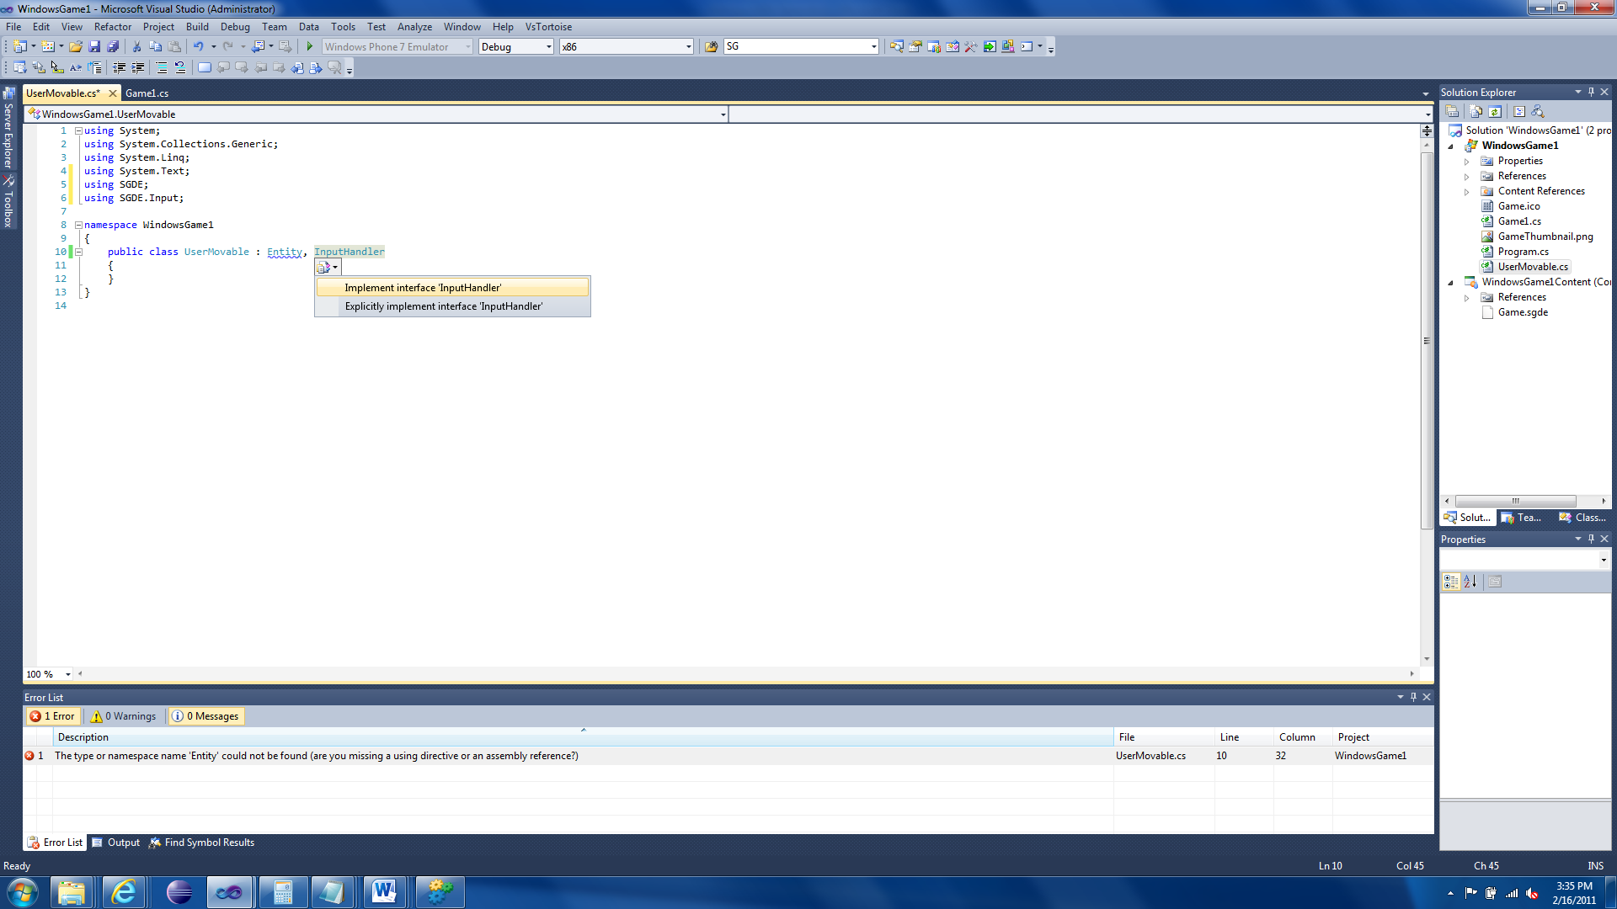

A bunch of code should appear.

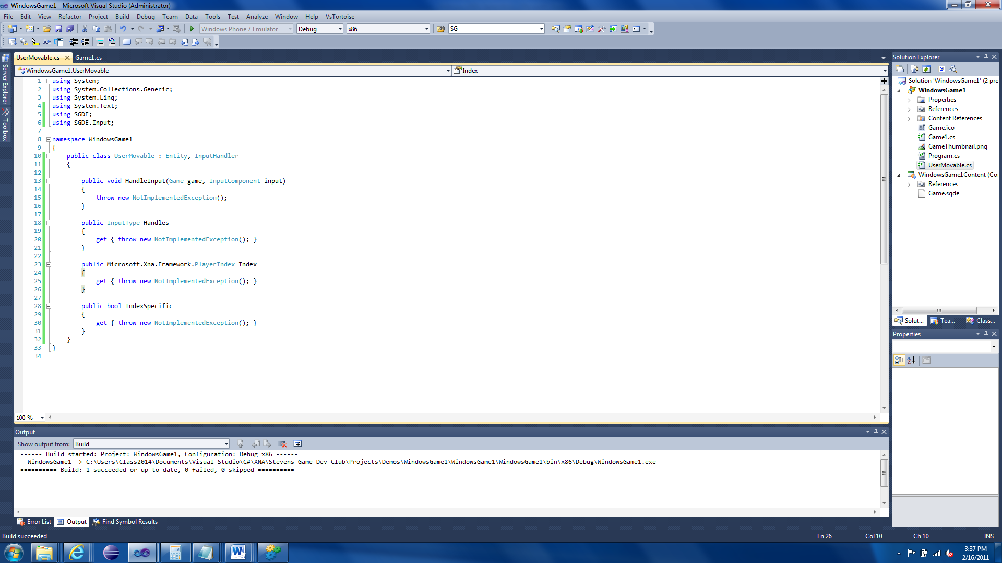

We need to replace all those “throw new NotImplementedException();” lines. First in the Handles property, replace the exception with “return InputType.Keyboard;”. For Index replace the exception with “return Microsoft.Xna.Framework.PlayerIndex.One;”. Finally replace the IndexSpecific property’s exception with “return false;” Your code should now look like this:

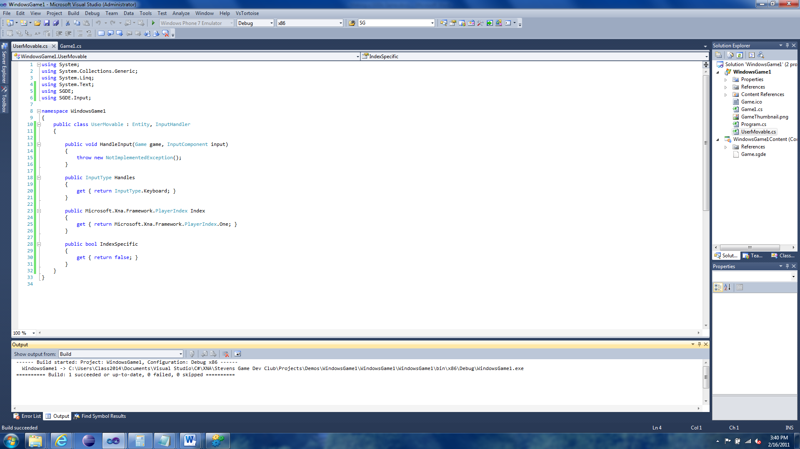

For the HandleInput function, replace it with:

public void HandleInput(Game game, InputComponent input)

{

SGDE.Input.Keyboard keyboard = (SGDE.Input.Keyboard)input;

if (keyboard.IsKeyPressed(Keys.Left))

{

this.Translate(-5, 0);

}

if (keyboard.IsKeyPressed(Keys.Right))

{

this.Translate(5, 0);

}

if (keyboard.IsKeyPressed(Keys.Up))

{

this.Translate(0, -5);

}

if (keyboard.IsKeyPressed(Keys.Down))

{

this.Translate(0, 5);

}

if (keyboard.IsKeyClicked(Keys.Escape))

{

game.Exit();

}

}

This code uses the arrow keys to move the Sprite around the screen.

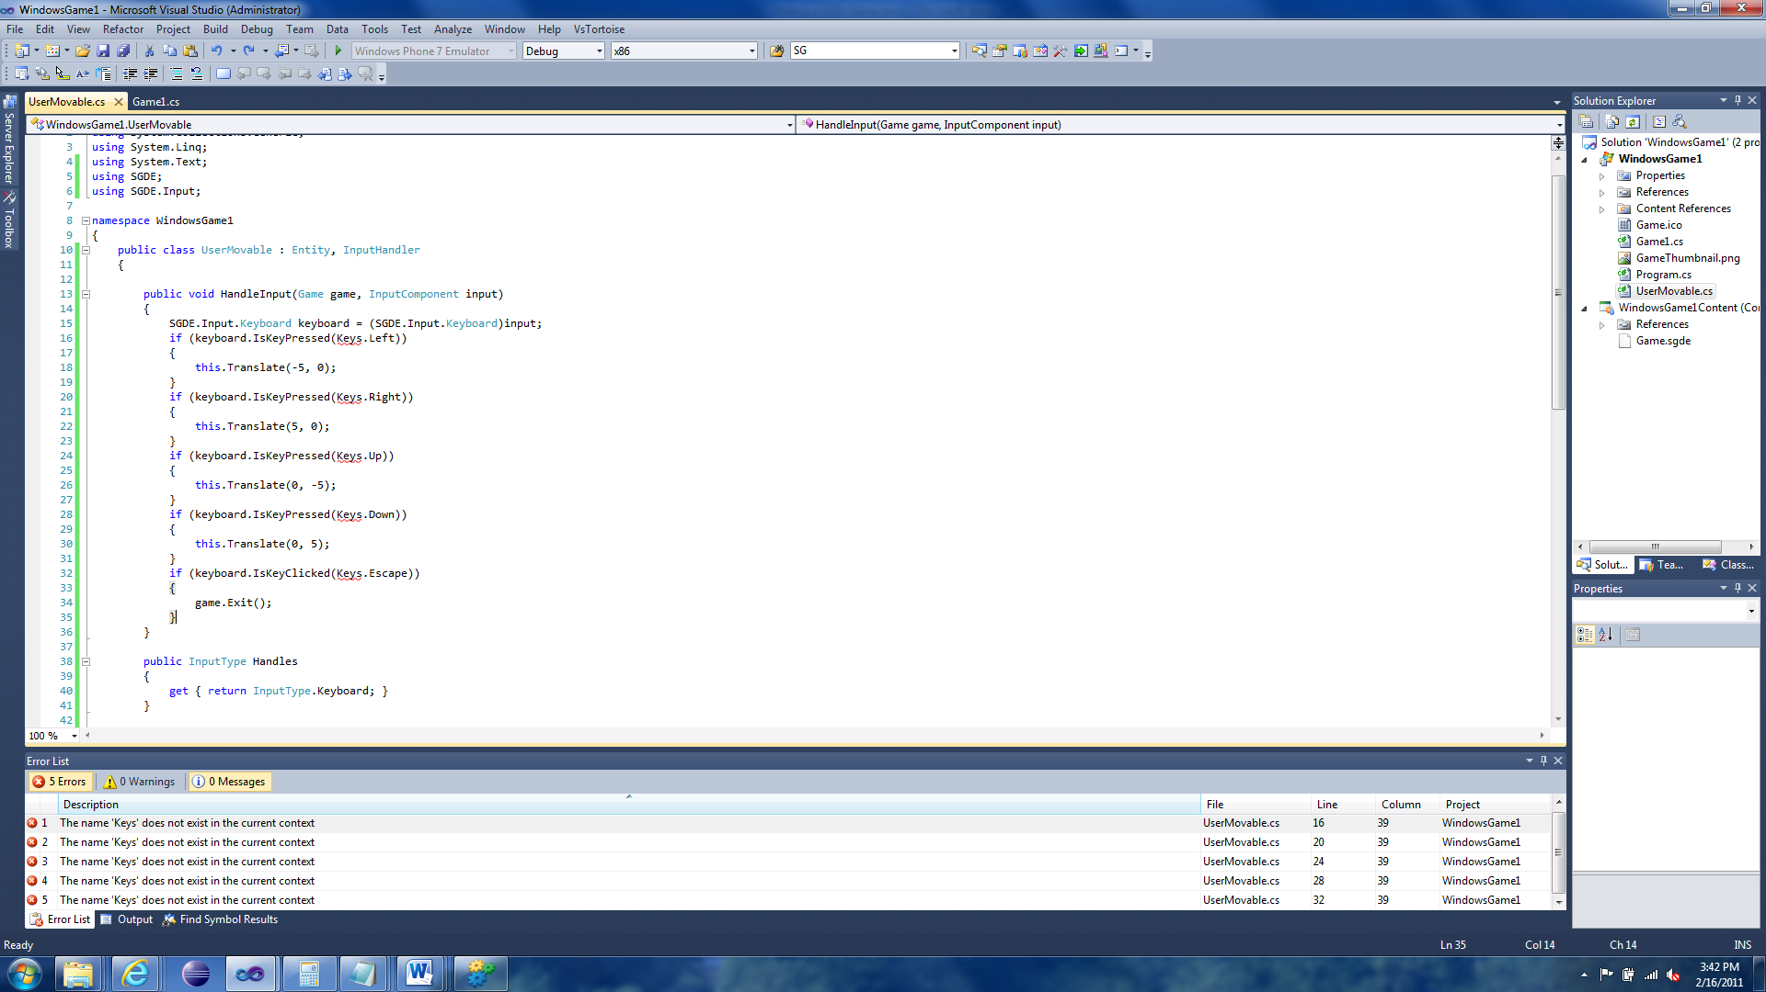

“But now I get an error with ‘Keys’?” Just like with the Entity and InputHandler. Click one of the “Keys”, the arrow, dropdown, and select “using Microsoft.Xna.Framework.Input;”

Now compile and run.

You should be able to move the Sprite around the screen. This is mine:

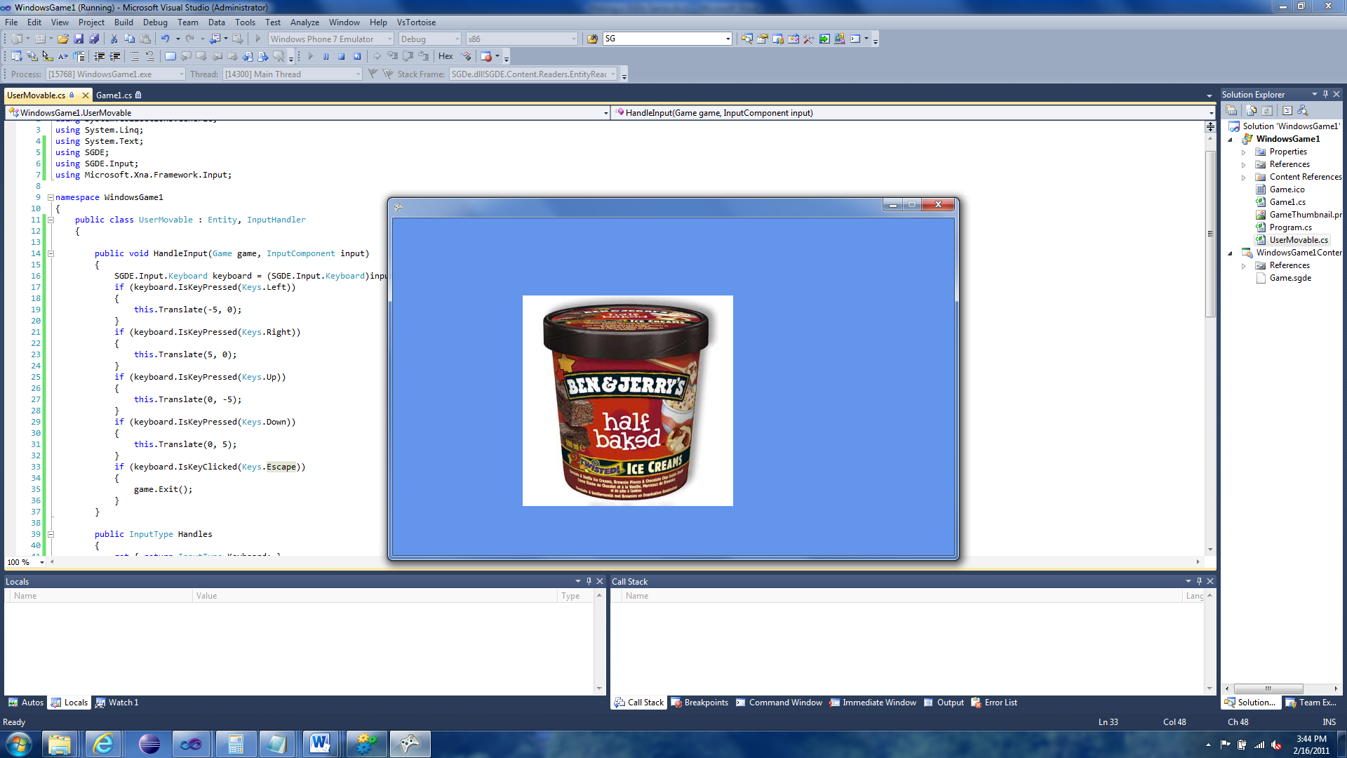

That wasn’t that hard was it?